*Spine*

Acad Year 2017/2018

Project No. (A035)

AUTOMATIC DOCKING AND CHARGING STATION FOR A MOBILE ROBOT PLATFORM

*Cover*

**AUTOMATIC DOCKING AND CHARGING STATION FOR A MOBILE ROBOT PLATFORM**



POON JUN NAM

SCHOOL OF MECHANICAL AND AEROSPACE ENGINEERING

NANYANG TECHNOLOGICAL UNIVERSITY

Year (2018/2019)

*Title Page*

**AUTOMATIC DOCKING AND CHARGING STATION FOR A MOBILE ROBOT PLATFORM**

SUBMITTED

BY

POON JUN NAM

SCHOOL OF MECHANICAL AND AEROSPACE ENGINEERING

A final year project report

presented to

Nanyang Technological University

in partial fulfilment of the

requirements for the

Degree of Bachelor of Engineering (Mechanical Engineering)

Nanyang Technological University

Year 2018/2019

ABSTRACT

Automation has been gaining attention recently and has been widely adopted by companies from various field, resulting from the research works put into robot technology in the past. The mobile robot is one of the core focus of current research, this is because not only the companies in the industrial sector will be benefit but also the service sector.

The main characteristic of a mobile robot is that it carries its own power supply, the battery. Hence, for the robot to be fully automated, the robot is required to detect low battery level and proceed to charging station for battery recharge by itself without human intervention.

In this report, various techniques in achieving the automation of battery charging of a mobile robot will be discussed, in both software and hardware perspective. For software, experiment on different marker libraries will be carried out and selection of marker libraries will be discussed. For hardware, the discussion will be focused on the mechanical design of the contact surface between the station and the robot.

ACKNOWLEDGEMENT

I would like to express my sincere gratitude to my parents for their absolute support during my bachelor study and my Final Year Project. Besides, I would like to take this chance to thank the following people, including but not limited to, who had help and support me along my Final Year Project.

Firstly, I would like to thank my supervisor, Associate Professor Seet Gim Lee, Gerald for giving me this opportunity to work on this project, including his mentorship and guidance throughout the whole project.

Secondly, I would like to thank my mentor, Mr Burhan for his guidance and assistance on my project, which has helped me to gain insight into research work and accelerated the progress of my project.

I would also like to thank Ms Pang Wee Ching for her valuable suggestion on the project and assistance on technical issues. Not to mention the staff of Robotic Research Laboratory 1 who has given full support to my enquiries.

**Table of Contents**

ABSTRACT 3

ACKNOWLEDGEMENT 4

LIST OF FIGURES 7

LIST OF TABLES 8

1. Introduction 9

1.1 Background 9

1.2 Objective 10

1.3 Scope 11

2. Literature Review 12

2.1 Past Research Done 12

2.2 Previous FYP Work Done 13

2.2.1 Hardware 13

2.2.2 Software 14

3. Implementation 15

3.1 Hardware 15

3.1.1 MAVEN 15

3.1.2 Peripherals 17

3.2 Software 18

3.2.1 ROS Nodes and ROS Topics 18

3.3 Libraries Selection 20

3.3.1 Inaccuracy of Orientation Data 20

3.3.2 Experiment Setup 22

3.3.3 Experiment Result and Discussion 23

3.3.4 Final Selection 25

3.4 Pose Determination 26

3.4.1 Position Determination 26

3.4.2 Orientation Determination 26

3.4.2.1 One Marker 27

3.4.2.2 Two Markers 28

3.5 Algorithm 33

3.5.1 The Docking Algorithm 34

3.5.2 The Laser Docked Check Algorithm 38

3.5.3 Parameters and Fine Tuning 40

3.6 Charging Station Framework and Placement 43

4. Experiment 46

4.1 Experiment Setup and Procedure 46

4.2 Experiment Data 47

5. Result and Discussion 48

5.1 Result 48

5.2 Discussion 51

6. Conclusion 51

References 52

Appendix 54

LIST OF FIGURES

Figure 1: Charging Station from Previous FYP Work 13

Figure 2: Based Holonomic Platform of MAVEN 15

Figure 3: Contacting Charger when Not Charging 16

Figure 4: Contacting Charger when Charging 16

Figure 5: Camera and Laser on Robot 17

Figure 6: Overview of Nodes and Topics 18

Figure 7: Overview of Nodes and Topics 19

Figure 8: Data Screenshot of Marker in Middle 20

Figure 9: Data Screenshot of Marker in Middle Tilted 20

Figure 10: Data Screenshot of Marker in Left 21

Figure 11: Data Screenshot of Marker in Right 21

Figure 12: Setup of 1 Marker 22

Figure 13: One Marker Calculation 28

Figure 14: Marker 0 29

Figure 15: Marker 1 29

Figure 16: Setup of 2 Markers 29

Figure 17: Two Markers Calculation 1 30

Figure 18: Two Markers Calculation 2 31

Figure 19: Overview Flow Chart 34

Figure 20: Robot Navigation System Direction 35

Figure 21: Docking Algorithm Flow Chart 36

Figure 22: Position of Robot at Check Point 37

Figure 23: Final Check Flow Chart 39

Figure 24: Orientation Check with Laser 40

Figure 25: First Version of Charging Station Framework 43

Figure 26: Second Version of Charging Station Framework 43

Figure 27: Final Version of Charging Station Framework 44

Figure 28: Charging Station Placement 45

LIST OF TABLES

Table 1: List of Nodes and Functions 19

Table 2: Result of the ar_pose Library Test 24

Table 3: Result of the ar_track_alvar Library Test 24

Table 4: List of Parameters in Docking Algorithm 41

Table 5: List of Parameters in Laser Docked Check Algorithm 41

Table 6: List of Parameters in hokuyo1 Node 41

Table 7: Time Required for the Standard Actions 48

Table 8: Result for Scenario 1 48

Table 9: Result for Scenario 2 48

Table 10: Result for Scenario 3 49

Table 11: Result for Scenario 4 49

Table 12: Result for Scenario 5 49

Table 13: Result for Scenario 6 50

Table 14: Result for Scenario 7 50

Table 15: Average Result of All Scenarios 51

1. Introduction

## Background

A robot is a machine that can perform a series of complex motions automatically and is programmable by a computer[1]. Because of this property, robot is widely adopted in many sectors of industry to automate processes. Before this concept is introduced, human labours were used in the factory for production and this was changed because of the remarkable event in 18 centuries, the industrial revolution. Almost all the works that were done by human labours in the factory was replaced by the machine, the main reason is that cost of labour is too high and machinery is a good alternative for replacement during that time[2]. The idea of robot started when the machine is combined with the computer program, and this gained popularity among industry sectors. Besides, due to the advancement of technology in sensors, robots can now perform more accurate and precise work than human, especially for repeatable work.

For the past few decades, the attention given to robots has been increasing, a lot of works and researches have been put into this field. The reason behind this is the surging demand to automate a large number of processes and work such as heavy lifting, repeatable work like supply chain packaging, production line, manufacturing process and others[3]. This is indeed affected by the industrial revolution. Besides, automation with robots technology can reduce labour cost[4], human error, and increase efficiency in the long run for highly repeatable works. Nowadays, automation in the industry is very common and popular, most of the production and manufacturing processes are replaced by robots to achieve automation[4], and the requirement for automation in industries is getting higher. Most of the robots implemented in the supply chain or the manufacturing processes are stationary robots.

In recent years, with the technology improvement of the internet, e-commerce is experiencing more demands and attention. The main differences between e-commerce and the traditional retail shops are the online product browsing service and the home delivery service. Therefore, because of the home delivery service, e-commerce has more additional steps in logistics than the traditional retail shops. The biggest challenge faced by e-commerce in logistics is the warehouse logistics[5]. There are several steps in e-commerce warehouse logistics, mainly are the order picking, transport to packing area and the packing operations. To be more precise, the challenge in e-commerce warehouse logistics is the order picking and transportation steps. The cost of logistics in e-commerce is 40% of the total cost paid by customers[6]. In addition, China logistics contributed 17.9% toward the GDP of mainland China[7]. However, stationary robots cannot fully automate the whole process in the warehouse logistics of e-commerce due to the immobility of stationary robots. From then on, the research on robot has shifted from stationary robots, which serve periodic or repeated work, to mobile robots[8][9]. Besides, the industrial robots are developing and adopting mobile robots into industrial application[10].

The distinct feature between stationary robots and mobile robots is mobility. The main reason that causes the immobility of stationary robots is the need for wire connection for power supply. The mobility is not a significant factor in factory automation and hence stationary robots are widely adopted in that field. To achieve mobility, mobile robots have to carry a battery with it, while to achieve full automation, the mobile robots are required to proceed to the charging station for battery recharge when the battery level is low, with minimal or no human intervention. Hence, there is a need to enhance the intelligence of mobile robots for it to detect the low battery level, and a docking system is required to be developed to automate the process of battery recharge.

## Objective

In this project, the aim is to develop a low-cost solution which enables the mobile robot to perform the process of automatic docking and charging. A docking system is required, which consist of a docking algorithm and a charging station. The solution has to achieve the requirement of only one active side and one passive side. Therefore, no active peripherals are to be implemented on the station such as camera, infrared sensor, laser and others. This is to keep the solution at a low cost and affordable range. Besides, the solution will be easier to implement since there are no communications between the robot and the station.

## Scope

This project is based on the assumption that the robot is near the charging station when the docking algorithm started, so the focus of this project is on the docking and charging, instead of the navigation to the docking station.

This project will cover the selection of the library, where the library is used to detect the marker which will be placed on the charging station to act as a landmark. Besides, the pose estimation of the robot will be investigated. Several methods and calculations will be developed and discussed based on the data available. Next, the algorithm development will be covered and there is also a discussion of the framework of the charging station.

1. Literature Review

## Past Research Done

In the recent years, mobile robots are widely adopted by various industry sector due to its mobility and ability to perform various tasks and applications such as cleaning, security, logistics, entertainment, military, dangerous environment, surgery, service and others[9][11]. To achieve a fully autonomous system with mobile robots, the energy required for the robot to function becomes an important topic to be researched. Several types of research regarding this topic have been done and the autonomous charging system with the docking station was proposed.

The first research done on robot recharging is by Grey Walters[12], where the robot will find its way to a hut to recharge by using the light. Yuta and Hada have proposed a solution for mobile robots recharging in the late 1990s. The mobile robots will reach the station for charging with the help of the reflective tape on the floor and the infrared sensors[13]. Another solution proposed in the late 1990s to perform the docking is implemented with the vision-based technique[14]. Another research used 4 IR LED emitters and 1 IR receiver to achieve the docking. The method allows a 6 degree of freedom(DOF) when the robot enter[15].

In recent decades, research on docking and autonomous recharging is still very active. In 2002, Silverman proposed a solution which makes use of the vision and laser beacons to locate the station. The station was designed with 2 DOF to provide a high angular and displacement error during the docking process[16]. For the proposed solutions in [11][17], the mobile robots will locate the station and perform the homing with the help of the IR sensors at the station. The IR sensors at the station are to detect the presence of the robot. In this case, there are 2 active sides in the system and hence communication and data transfer are required between the robot and the station. There is another research which employs 1 active side on the robot and 1 passive side on the station in [9]. The mobile robots will locate the station through an artificial landmark and estimate its pose. The virtual spring method is proposed in the paper to achieve the docking. The station was designed with 2 DOF to allow some error during the docking.

## Previous FYP Work Done

The work done by the previous FYP student covers the hardware and the software aspect. Both aspects are reviewed in the following section. The result of the previous work achieved a success rate of 80% out of 50 attempts.

### Hardware

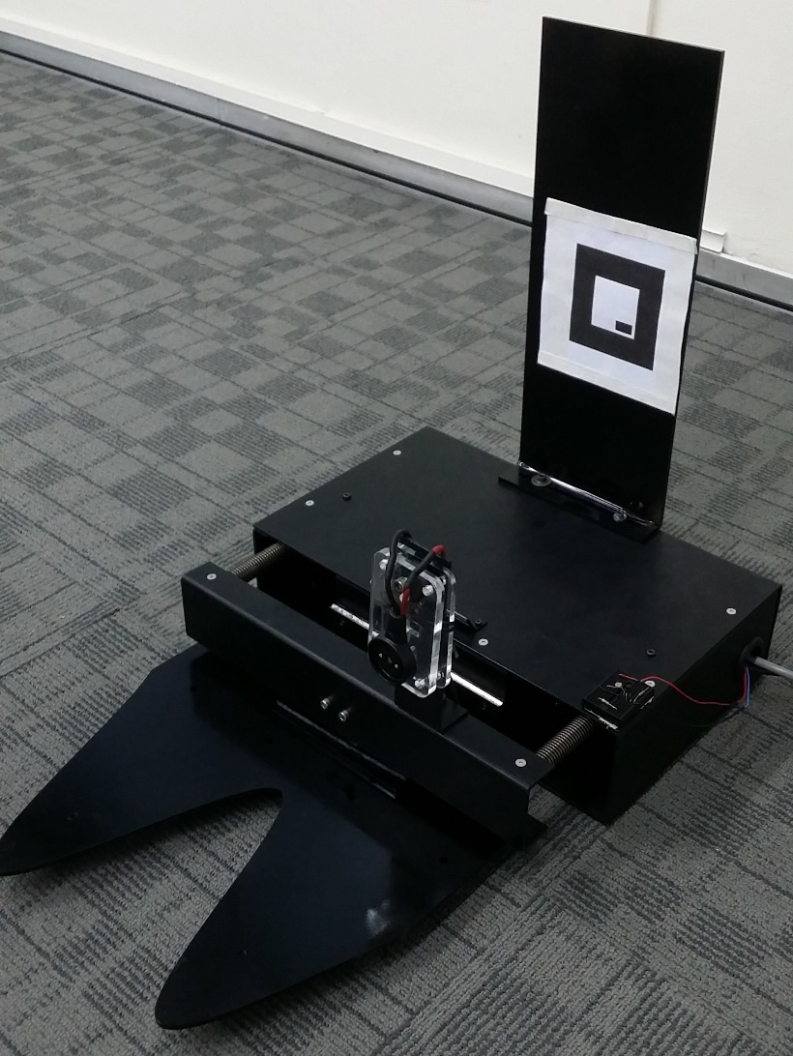The station done consist of mainly 3 parts, the alignment plate, the backing box and the stand to hold the marker in place, as shown in Figure 1. The design of this station follows a structured process, the functional analysis, morphological stage and embodiment design principal.

Figure 1: Charging Station from Previous FYP Work

The alignment plate of the station has 2 degrees of freedom (DOF) with the revolute joint and the slider. This mechanism has improved the functionality and reliability of the station where the station can accommodate an error of 30 degrees for the docking process.

### Software

The docking algorithm from previous FYP work is able to complete the docking process with the error allowance provided by the station. This is because the algorithm heavily relies on the IMU to correct the heading of the robot. Hence, there is a space for improvement for the docking algorithm.

Besides the docking algorithm, the software work from the previous FYP work also covers the whole battery charging process. After docked successfully, the algorithm will constantly check the battery level and provide a signal once the battery is fully charged. Then, the robot can leave the station and continue its work. The robot can utilize this function and increase its overall efficiency.

The steps required to start the robot is a rigmarole. Hence, the roslaunch function provided by ROS[18] is utilized and a launch file is created in this project.

1. Implementation

## Hardware

### MAVEN

The mobile robot that is used in this project is the base holonomic platform of Mobile Avatar for Virtual Engagement by NTU (MAVEN). MAVEN is developed by Associate Professor Gerald Seet et al. for the purpose of enabling the user to attend an overseas meeting or conference without the need to leave the office or home country[19].

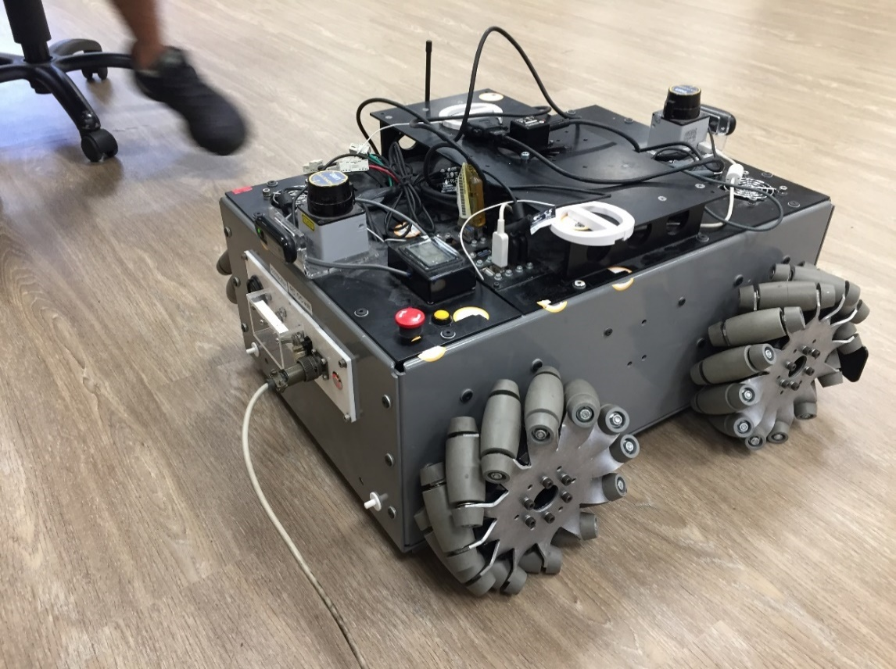The base platform of MAVEN, as shown in Figure 2, houses the PC, the mecanum wheels, the Galil Motion Controller, the power supply, the batteries and a series of sensor peripherals and actuators.

Figure 2: Based Holonomic Platform of MAVEN

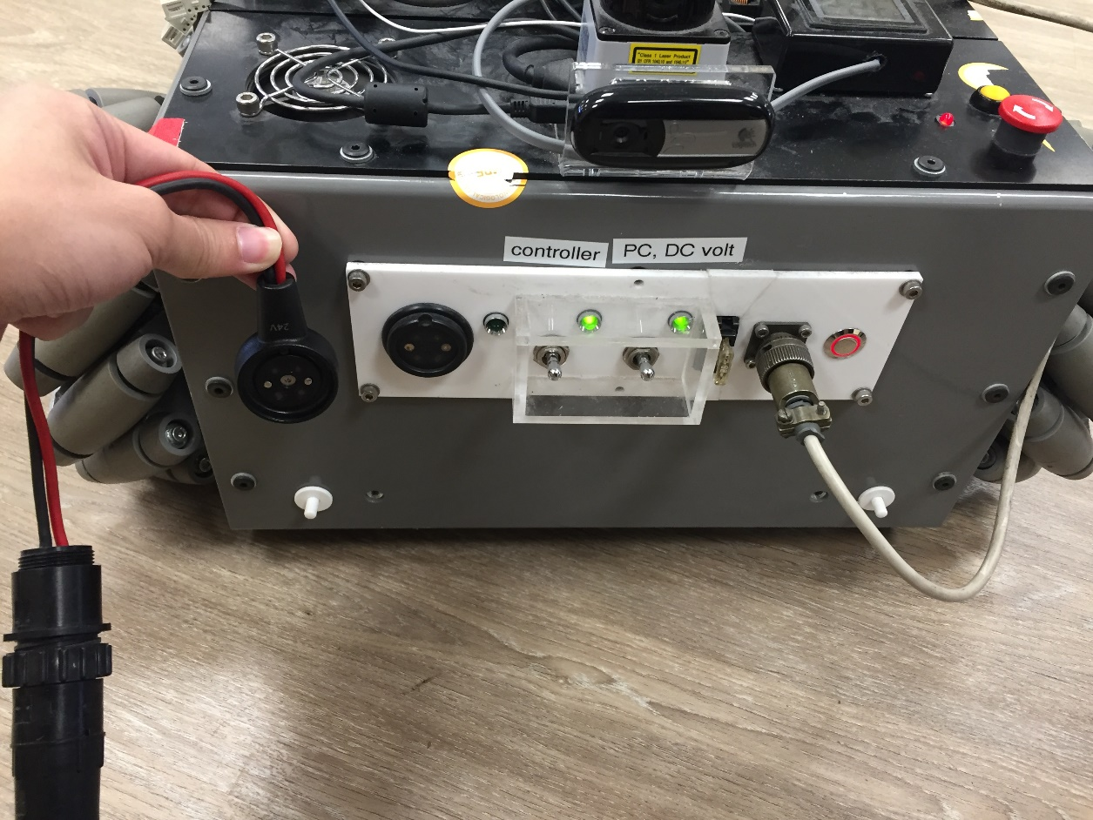The charger type for MAVEN is the normal contact charger, as shown in Figure 3 and Figure 4. Hence, the accuracy of the docking must be very high. The wireless charger is another solution which can provide a larger tolerance for error in pose, but in this project, the focus will be on the docking for the contacting charger. This is because if the algorithm can dock the robot successfully or with some slight error, the same algorithm can be used for the wireless charger.

Figure 3: Contacting Charger when Not Charging

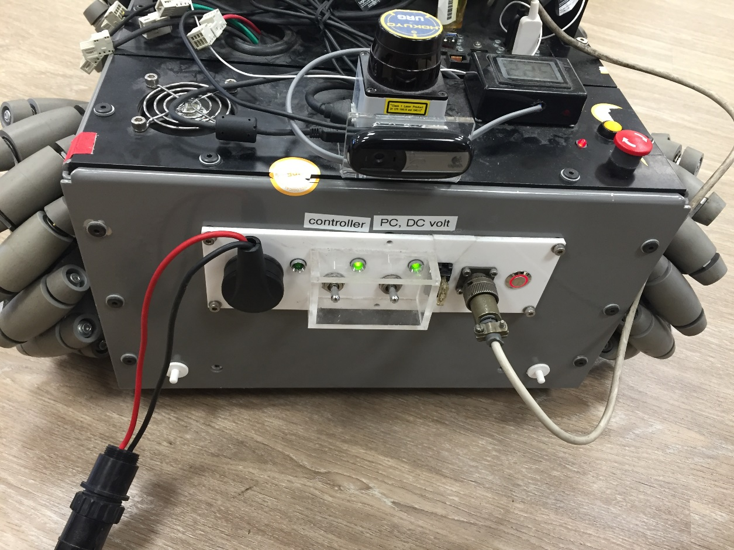

Figure 4: Contacting Charger when Charging

### Peripherals

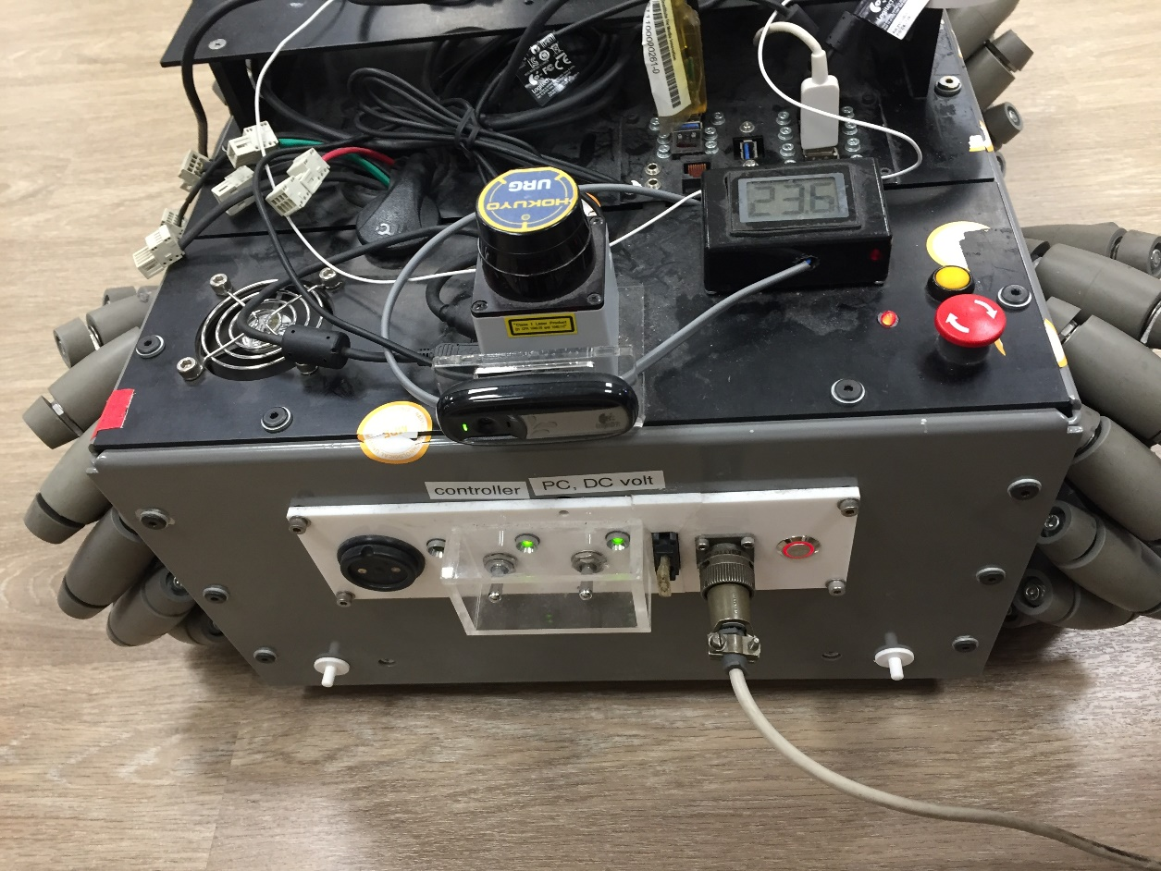In this project, the peripherals used to detect the surrounding and locate the station are the monochrome camera and the Hokuyo URG-04LX Laser Range Finder. The position of the camera and the laser on the robot is shown in Figure 5.

Camera

Hokuyo Laser

Figure 5: Camera and Laser on Robot

There are 2 units of cameras and lasers mounted on the two sides of the robot, which can be seen in Figure 2. One camera and one laser are used in this project, which is the camera and the laser mounted on the side of the charging port. This is because of the assumption that the robot will be near the charging station and the side of the charging port will be facing the charging station when the docking algorithm started. The camera and the laser on the other side can be used to improve the generality and the usability of the docking algorithm in the future.

## Software

In the software aspect, the control of the robot is performed on the Robot Operating System (ROS) which operates on the Linux Operating System. ROS has the functionality to compile and run every single algorithm or source code in a single node, where the node will communicate with another node through publishing or subscribing to the related topic. The idea of nodes and topics in ROS is very good for algorithm development in an organized structure and the ease of maintenance in the future. On the other hand, the programming language C++ will be used to develop the algorithm, while complimenting with XML.

### ROS Nodes and ROS Topics

Figure 6 and Figure 7 shows the overview of nodes and topics used in this project to achieve the automatic docking and charging for a mobile robot. Figure 6 is grouped with namespace while Figure 7 is not.

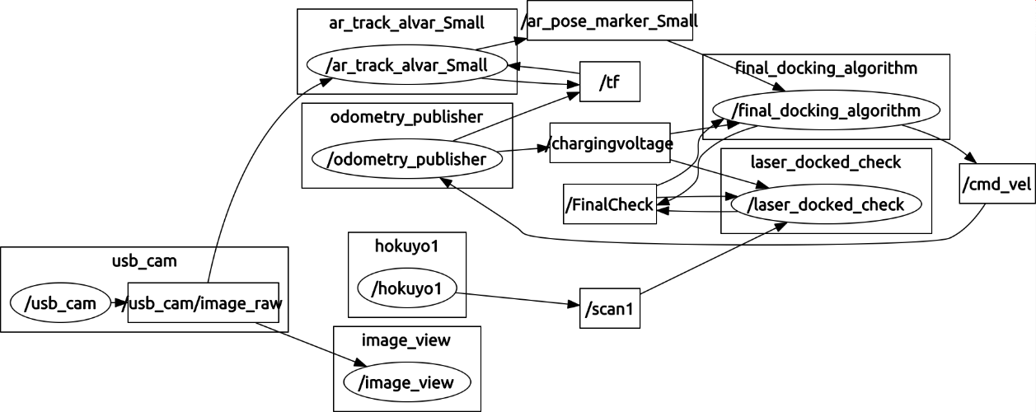

Figure 6: Overview of Nodes and Topics

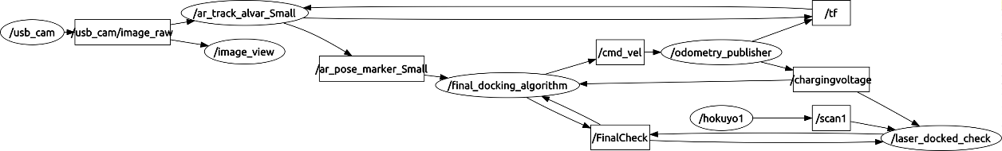

Figure 7: Overview of Nodes and Topics

In both Figure 6 and Figure 7, the oval shapes are the nodes and the rectangle shapes are the topics. Table 1 shows the list of nodes and the function respectively.

Table 1: List of Nodes and Functions

|  |  |
| --- | --- |
| Nodes | Function |
| /usb_cam | To get the camera feed from the camera |
| /image_view | To show camera feed to the user on the screen |
| /ar_track_alvar_Small | To detect markers and provide distance data between the marker and the camera |
| /hokuyo1 | To provide distance data from Hokuyo Laser Range Finder |
| /final_docking_algorithm | The docking algorithm using markers data from the camera |
| /laser_docked_check | The final check algorithm using data from Hokuyo Laser Range Finder |
| /odometry_publisher | To output and send the desired velocity command to the controller |

## Libraries Selection

There are 2 choices of libraries for markers detection, ar_pose and ar_track_alvar. Ar_pose library was the library used by the previous student, back in 2015, while the other library ar_track_alvar is widely used by other developers in 2018.

Both libraries provide the basic function of markers detection and distance calculation from the markers. Both libraries have their own specific markers for detection and the ar_track_alvar library has more markers available than ar_pose. Besides, ar_track_alvar[20] is better documented and maintained as compare to ar_pose[21].

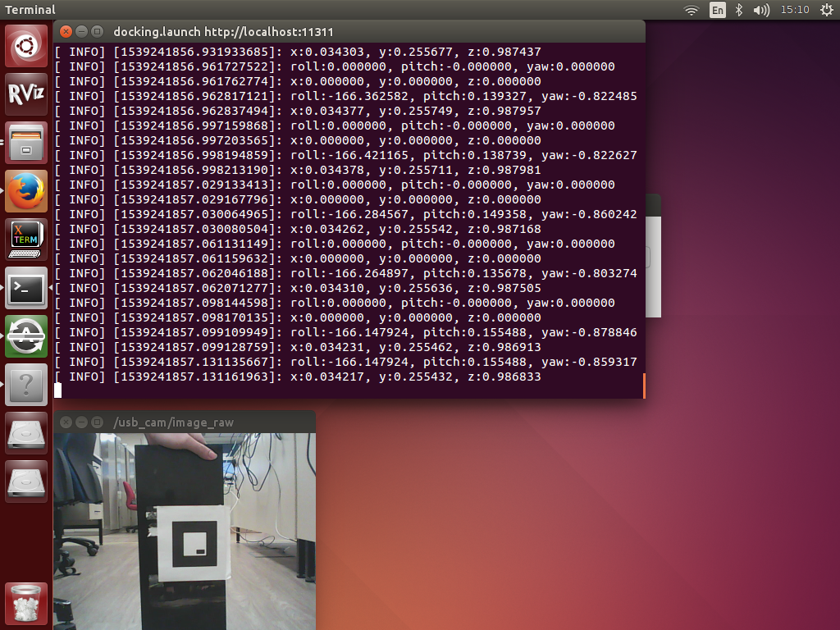From these 2 libraries, one has to be chosen and to be used in this project. Hence, an experiment was carried out to test the accuracy of the 2 libraries.

Figure 8: Data Screenshot of Marker in Middle

### Inaccuracy of Orientation Data

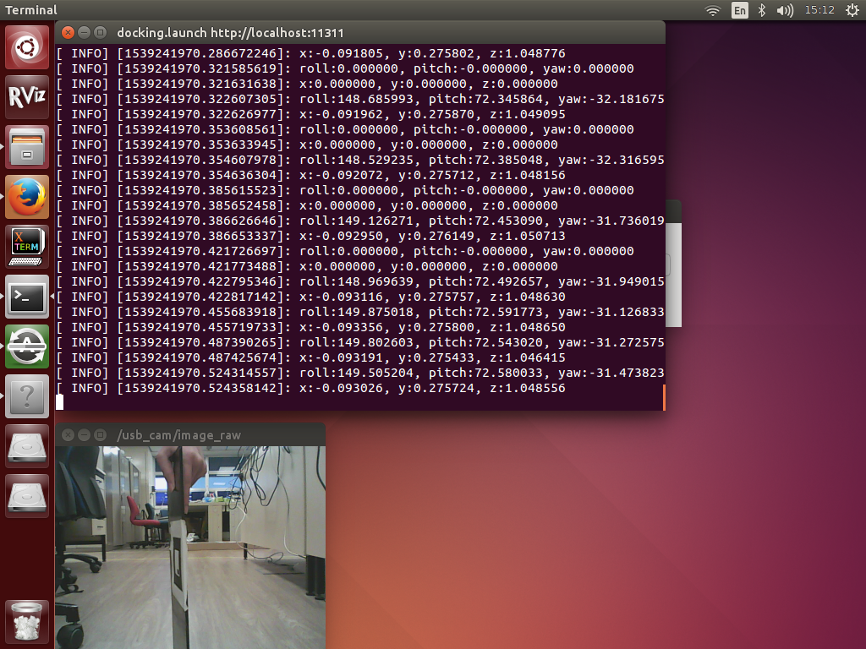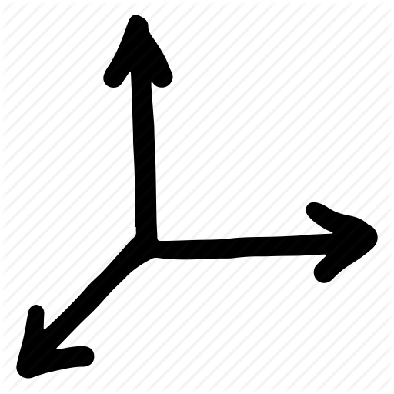A simple test was carried out before the experiment and the result showed that the orientation data provided by the library is highly not reliable, as shown in figures below.

Z

Y

X

Figure 9: Data Screenshot of Marker in Middle Tilted

From the data shown in the figures, the roll, pitch and yaw are the orientation data. With respect to the coordinate system shown in the figure, the roll is the rotation about the z-axis, the pitch is the rotation about y-axis and yaw is the rotation about the x-axis. In this case, we are only concern about the pitch, the rotation about the y-axis, which represents the heading of the robot with respect to the marker.

In Figure 8 and Figure 9, the camera feed and the data are output in a real-time manner. By comparing the camera feed with the data, we can notice that the pitch is quite accurate when the marker is in the middle or when x equal to 0m.

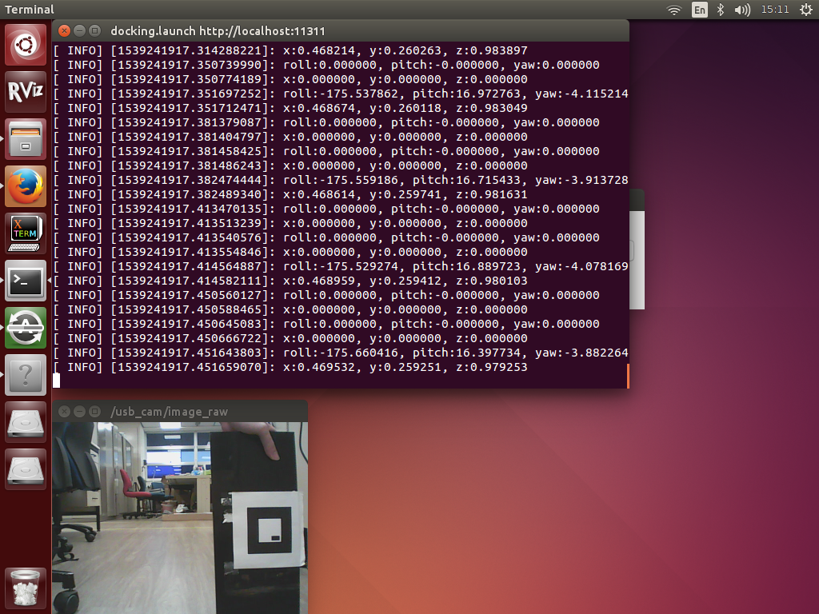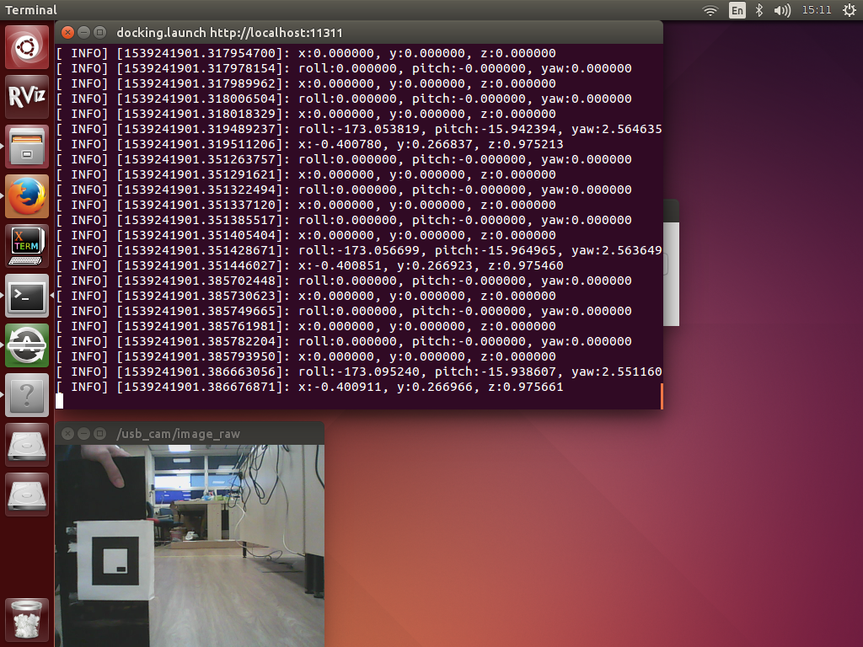

Figure 10: Data Screenshot of Marker in Left

Z

Y

X

However, in Figure 10 and Figure 11, when the marker was placed on the left side and the right side of the camera, the data of pitch is not correct. By judging from the camera feed, the orientation of the robot to the marker should be the same, meaning around 0 degrees of pitch angle, but the data was showing around 16 degrees of pitch angle.

Figure 11: Data Screenshot of Marker in Right

Therefore, the orientation data provided by the libraries is deemed to be not reliable, the data will not be measured and recorded in the experiment.

### Experiment Setup

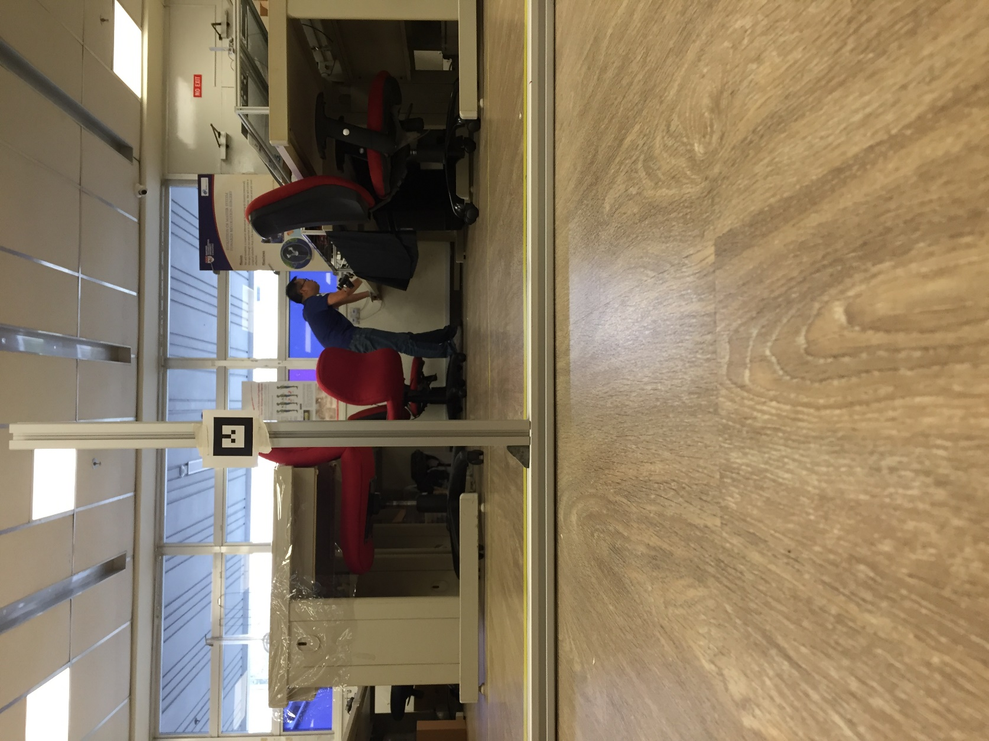This experiment is conducted to compare the accuracy of the translational data provided by the library. The experiment is set up as shown in Figure 12. The marker was placed on a steel bar and distance retrieved from the library was compared with the ground truth to visualize the accuracy of the respective library.

Y

X

Z

Figure 12: Setup of 1 Marker

Each library was tested with different distance value due to the marker detectable range and marker size of the library itself. The difference in experimental value for both libraries does not impose a significant impact as the values will be compared to the respective ground truth.

The ar_pose library was tested with 1.1m and 1.4m in the z-direction and 0m, 0.3m and -0.3m in the x-direction. The ar_track_alvar library was tested with 0.8m and 1.1m in the z-direction and 0m, 0.2m and -0.2m in the x-direction. Therefore, there will be 6 sets of data for each library.

First, the robot was moved to a fixed position, then the steel bar with the marker is set up in front of the robot with the distance of the first ground truth to be tested. The data from the library was recorded for 10 seconds by using the rosbag function inside ROS. Next, the steel bar was moved to the distance of the next ground truth to be tested and the data was recorded. The last step was repeated until all the distances were tested and recorded for that particular library.

Next, the marker was replaced to the marker of the other library. The same procedure from before was repeated with respective distance to be tested. The data recorded was processed by averaging all the data recorded within the 10 seconds and compared to their ground truth respectively.

In the procedure mentioned above, the steel bar was moved, instead of the robot, when changing the distance is because moving the steel bar to the intended distance is more accurate than moving the robot with the joystick.

### Experiment Result and Discussion

Table 2 and Table 3 shows the result of the experiment. In this experiment, the translation data in the y-direction is not our concern in this project so it was not measured and recorded. The orientation data was also not measured and recorded due to its inaccuracy discussed before.

Table 2: Result of the ar_pose Library Test

|  |  |  |  |  |  |
| --- | --- | --- | --- | --- | --- |
| Ground Truth (m) | | Data Recorded (m) | | Error (m) | |
| z-direction | **x-direction** | **z-direction** | **x-direction** | **z-direction** | **x-direction** |
| 1.1 | **-0.3** | 0.754 | -0.246 | 0.346 | 0.054 |
| **0.0** | 0.742 | 0.033 | 0.358 | 0.033 |
| **0.3** | 0.749 | 0.264 | 0.351 | 0.036 |
| 1.4 | **-0.3** | 1.052 | -0.394 | 0.348 | 0.094 |
| **0.0** | 1.039 | -0.031 | 0.361 | 0.031 |
| **0.3** | 1.053 | 0.327 | 0.347 | 0.027 |

Table 3: Result of the ar_track_alvar Library Test

|  |  |  |  |  |  |
| --- | --- | --- | --- | --- | --- |
| Ground Truth (m) | | Data Recorded (m) | | Error (m) | |
| z-direction | **x-direction** | **z-direction** | **x-direction** | **z-direction** | **x-direction** |
| 0.8 | **-0.2** | 0.546 | -0.186 | 0.254 | 0.014 |
| **0.0** | 0.571 | 0.009 | 0.229 | 0.009 |
| **0.2** | 0.545 | 0.197 | 0.255 | 0.003 |
| 1.1 | **-0.2** | 0.846 | -0.183 | 0.254 | 0.017 |
| **0.0** | 0.869 | 0.023 | 0.231 | 0.023 |
| **0.2** | 0.842 | 0.217 | 0.258 | 0.017 |

Overall, we can see that the accuracy of both libraries is not very high. In fact, only the translation in the x-direction is accurate.

Even though the data provided by both libraries is not accurate, we can notice that the translation data in the z-direction is consistent, which mean the data retrieved from the library is always around x meter different from the ground truth. With this consistency, we can modify in the algorithm to account for this x meter error and this will enable the translation data in both the x-direction and the z-direction to be reliable for use. However, the value of x meter is not used in the algorithm due to the implementation of the method of comparison which will be discussed in the algorithm section.

Due to the inaccuracy of the orientation data, the orientation data cannot and will not be used in this project. Therefore, a method and calculation were needed to determine the pose of the robot with only translation data in the x-direction and the z-direction.

### Final Selection

In the previous section, we can see that the accuracy of both libraries doesn’t differ much. Both libraries can only provide reliable translation data in the x-direction and the z-direction.

Eventually, ar_track_alvar is chosen because of its well documentation, and more variation of markers to choose. Moreover, ar_track_alvar is widely used by others so it will be more convenient and easier for discussion regarding this library.

## Pose Determination

The word pose is the combination of two words, position and orientation. Position is the distance of an object with respect to a specific point, or the origin in a coordinate system without the concern of the object’s heading. In other words, position is the location of an object and where the object is facing is not important in position estimation. On the other hand, orientation is the heading of an object without the concern of the location of the object.

From the previous chapter, the library can only provide two usable data which are the translation data in the x-direction and the z-direction. Therefore, before proceeding to the algorithms, a method has to be figured out to determine the pose of the robot with only translation data in the x-direction and the z-direction.

### Position Determination

The position of the robot is to know how far or how near the robot is from the charging station. The position of the robot can be known by retrieving the translation data from the library.

The data in the z-direction indicate how far, in meter, the charging station is from the robot while the data in the x-direction indicate how much left or how much right, in meter, is the robot with respect to the charging station.

### Orientation Determination

The orientation data will be provided in the form of quaternion data from the library. The reason the quaternion system is preferred in robotic kinematic is that it can overcome the Gimbal Lock Problem in euler angle system. As discussed before, the quaternion data (orientation data) provided by the library is not accurate and not reliable enough to be used. If the quaternion data (orientation data) is accurate, the orientation of the robot can be known by doing a conversion from quaternion into euler angle, which is the degree angle system we are familiar with, using the formula shown below.

$$\left[\begin{matrix}∅ \\ θ \\ φ\end{matrix}\right]= \left[\begin{matrix}\tan^{-1}\left(\frac{2 \left(q_{0}q_{1}+ q_{2}q_{3}\right)}{1-2 \left(q_{1}^{2}+ q_{2}^{2}\right)}\right) \\ \sin^{-1}\left(2 \left(q_{0}q_{2}- q_{3}q_{1}\right)\right) \\ \tan^{-1}\left(\frac{2 \left(q_{0}q_{3}+ q_{1}q_{2}\right)}{1-2 \left(q_{2}^{2}+ q_{3}^{2}\right)}\right)\end{matrix}\right]= \left[\begin{matrix}Roll \\ Pitch \\ Yaw\end{matrix}\right]$$

Therefore, a calculation is required to determine the orientation by just using the translation data in the x-direction and the z-direction. Two calculations are developed, one with using one marker and the other with two markers. Further details of both calculations will be discussed in the following section.

#### One Marker

One trigonometry property between the translation data in the x-direction and the z-direction is that they are always perpendicular to each other. With this property, some trigonometry calculus can be performed to determine the orientation of the robot.

In Figure 13, the line $l_{1}$ is parallel to the marker and the line $l_{2}$ is parallel to the camera. One thing worth to notice is that the translation data in the z-direction is the distance between the marker and the camera which is perpendicular the line $l_{2}$, and is indicated as Z in the figure. The distance indicated as Z’ in the figure is the distance perpendicular to the marker, which is not the distance we will get from the library for the translation data in the z-direction. It is always the distance from the marker to the camera and is perpendicular to the camera, disregard the orientation of the marker as long as it can be detected by the camera.

The proposed solution with one marker is illustrated in Figure 13. The black box with number 1 indicated inside is the first position of the robot, the same goes for the black box with number 2 indicated inside. The red box with a letter M indicated inside is the position of the marker. The goal here is to find out the value of $θ$, which is the heading of the robot.

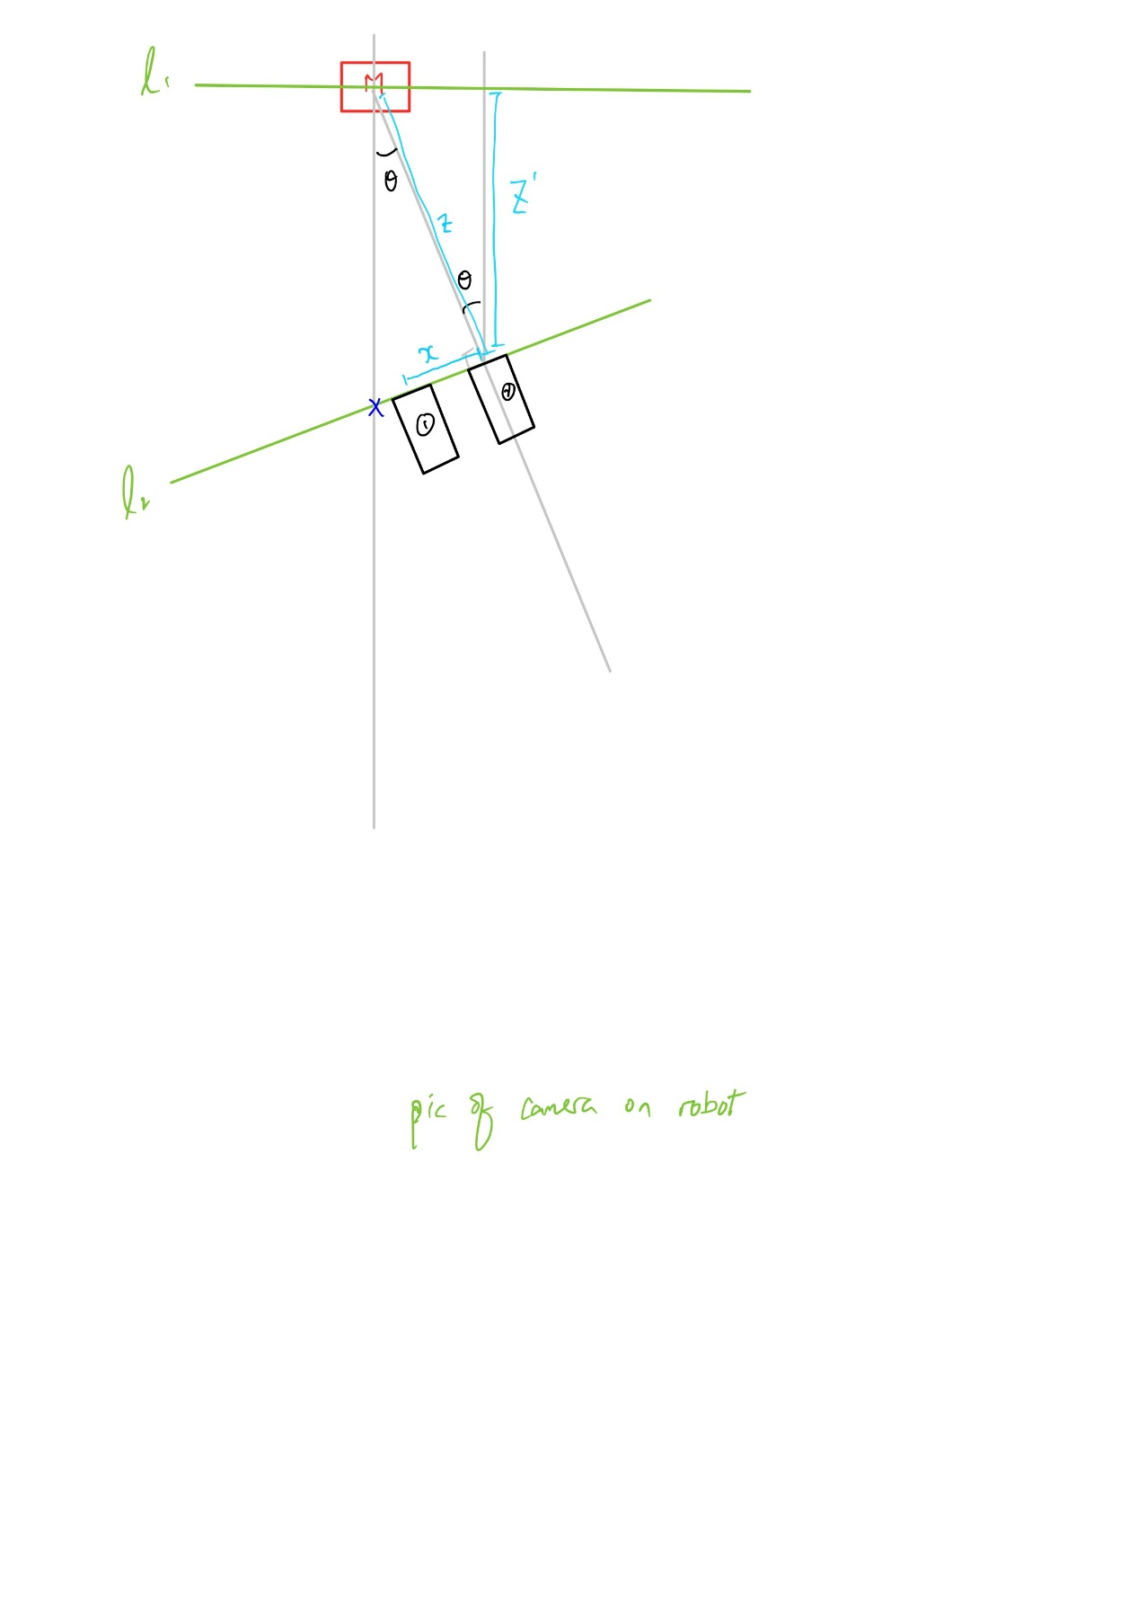

Figure 13: One Marker Calculation

When the robot is in the first position, 2 data are available, there will be some value larger or smaller than zero for both x and z. With the 2 available information, we can find out the value of the angles by using the equation below.

$$θ= \tan^{-1}\left(\frac{x}{z}\right)$$

However, to get the intended value of $θ$, the first position of the robot have to be at the blue cross indicated in Figure 13 in order to get the correct value for x.

Hence, this solution with one marker is not good enough to be used to estimate the pose of the robot, but this has provided a good foundation for the idea of using two markers for pose estimation.

#### Two Markers

The idea of using two markers was inspired by the idea of one marker and the concept of triangulation. From the one marker solution, it was a good solution for pose estimation but it was not good enough, because it can only estimate the pose of the robot at the certain location due to the insufficient of data. Hence, the idea of two markers comes into play because it can provide one more set of translation data in the x-direction and the z-direction. The two markers used are shown in Figure 14 and Figure 15, and Figure 16 shows the setup of the 2 markers.



Figure 14: Marker 0

Figure 15: Marker 1

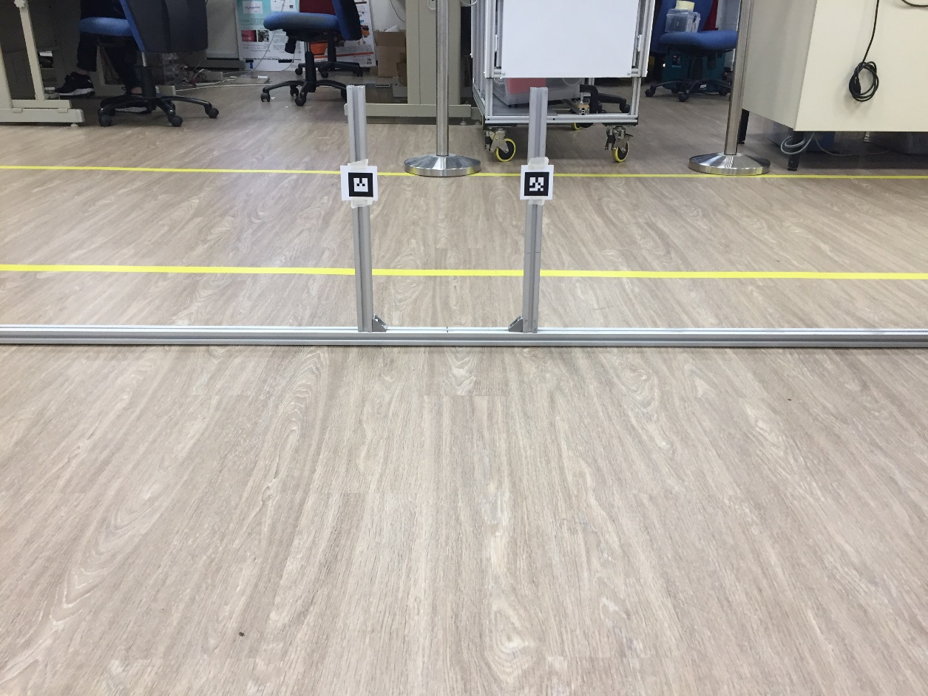

Figure 16: Setup of 2 Markers

Figure 17 shows the calculation for pose estimation by using two markers. The 2 red boxes with letter M indicated inside the box is the 2 markers, and the black box is the robot. The distance d between the 2 markers is predefined and it will be known when developing the algorithm. The line $l_{1}$ is parallel to the line $l_{2}$ and both the lines are parallel to the camera of the robot. The goal is still the same, to find the value of the angle $θ$.

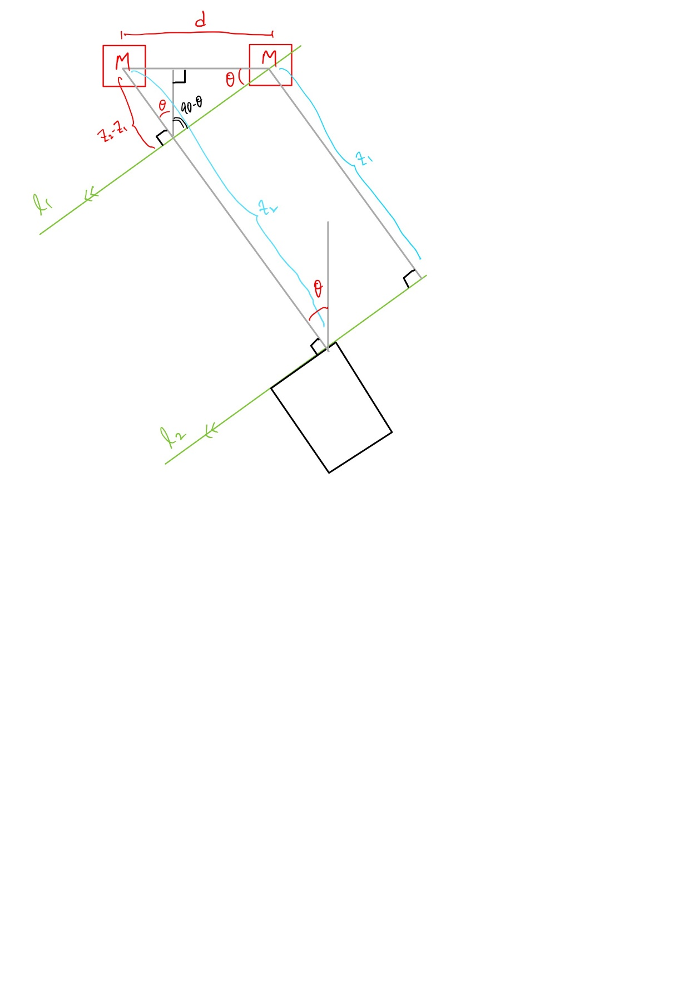As shown in Figure 17, there will be two translation data available in the z-direction. With some trigonometry property, the angle $θ$ at the robot can be transferred to the upper triangle formed by the two markers and the line $l_{1}$. At the upper triangle, with the distance d and the length perpendicular to the line $l_{1}$ known, the angle $θ$ can be determined by the equation below.

Figure 17: Two Markers Calculation 1

$$θ= \sin^{-1}\left(\frac{z_{2}-z_{1}}{d}\right)$$

With the formula above, the heading of the robot can be known. Hence, the pose of the robot can be determined with the information of the angle $θ$ and the translation data in the x-direction and the z-direction. This information can be utilized in the algorithm to correct the heading of the robot first before moving towards the charging station.

However, there is a small issue with the solution above of correcting the heading of the robot first. For example, the robot is at a location of extreme left or right such that after correcting the heading, the robot can only detect one marker. Therefore, based on the illustration in Figure 17, more calculation is performed and another solution with moving toward the centre first is shown in Figure 18.

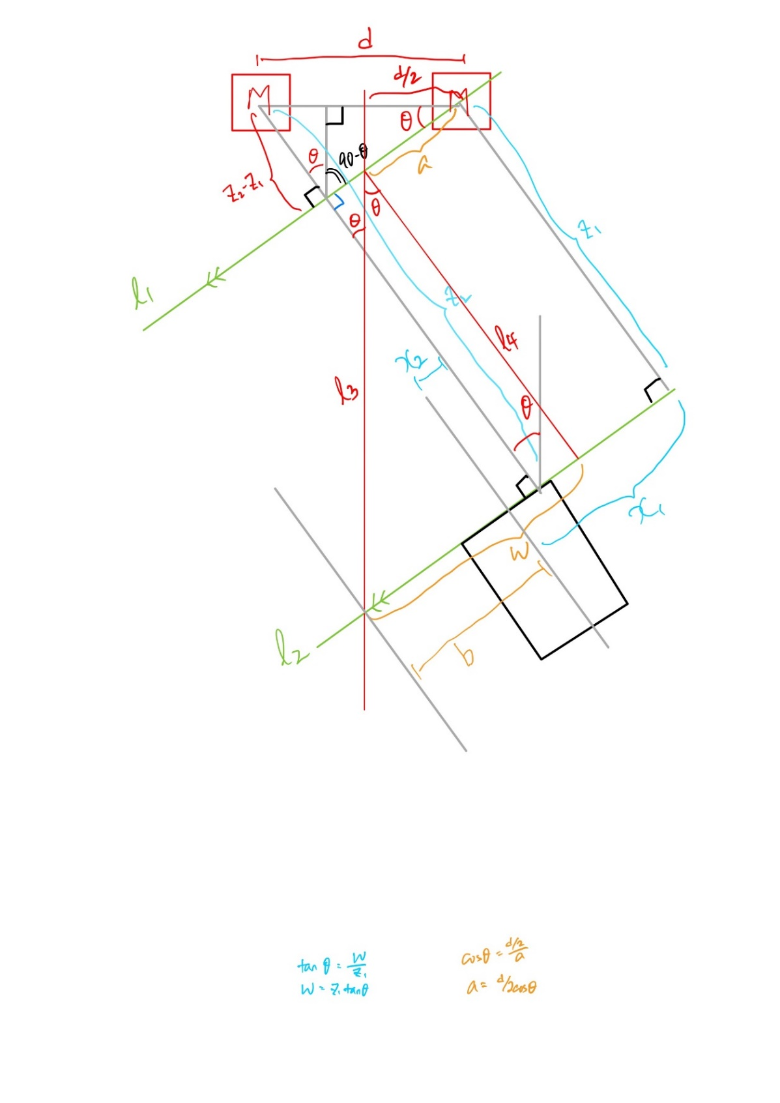

Figure 18: Two Markers Calculation 2

The illustration in Figure 18 is exactly the same as Figure 17, only with some addition of line $l_{3}$ and line $l_{4}$, and also the new lengths of $w, a, b, x_{1}, x_{2}$ and $d/2$. Some properties to note is that the line $l_{3}$ is the centre line between the 2 markers, hence the distance $d/2$, and the line $l_{4}$ is drawn from the intersection point between the line $l_{1}$ and the line $l_{3}$ to the line $l_{2}$, and is perpendicular to both line $l_{1}$ and line $l_{2}$. The goal here is to find out the value of distance $b$, the distance for the robot to reach the centre.

Notice that the distance $b$ can be obtained by:

$$b=w+a- x_{1}$$

There are three distances we need in order to obtain distance $b$, the distance $x_{1}$ can be retrieved from the library data, so we need to figure out the distance $w$ and $a$.

At the triangle formed by line $l_{2}, l_{3}$ and line $l_{4}$, we can notice that the length of line $l_{4}$ is $z_{1}$. Therefore, $w$ can be calculated by the equation below.

$$w= z_{1} × \tan{θ}$$

For the distance $a$, it can be figured out by looking at the triangle formed by the line $l_{1}, l_{3}$ and the line between the 2 markers. With the value of $d/2$ and angle $θ$ known, distance $a$ can be found by the formula shown below.

$$a= d/2 × \cos{θ}$$

Therefore, the idea of moving toward the centre first can be achieved by the solution shown above, to obtain the value of distance $b$.

## Algorithm

This algorithm is developed based on the assumption that the robot will navigate itself to the area near to the charging station for docking, hence this algorithm is only focused on the docking process and does not include the navigation system for the robot.

Both the solutions discussed before, the solution of heading correction first and the solution to move toward centre first, have their own advantages against the other. There is a possible way to fuse the idea of both solutions and hence this algorithm combined the idea of the solution discussed above, which mean this algorithm can provide the freedom for the robot to adjust its heading and at the same time move toward the centre.

Besides, due to the type of input and output, another approach is implemented in the algorithm. The method of direct comparison is used instead of distance and angle calculation. This is because if the method of distance and angle calculation is to be used, time will be a very important factor in the algorithm due to the formula speed equals distance over time.

For example, the distance is calculated and the desired velocity is output to the motion controller. In order to make sure the robot reaches the desired location, the time required for the robot to reach the desired position has to be known as well. On top of that, the algorithm has to keep track of the time had passed after sending the velocity command to the motion controller and has to stop the motion controller in time. This will result in the higher complexity of the algorithm and higher computing power for executing the algorithm continuously.

Hence, the method of direct comparison is more intuitive and easier to implement. More details about this method will be elaborated in the following section.

### The Docking Algorithm

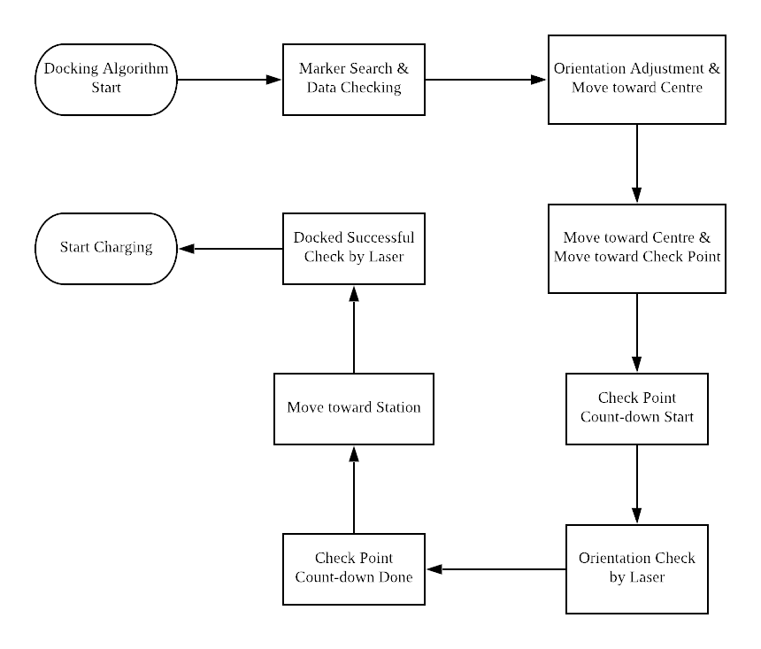The overview flow chart of the docking system can be seen in Figure 19. The algorithm of the docking system can be divided into 2 main parts, the docking part and the final step to move closer part. The flow chart of the docking part is shown in Figure 21 and the final step to move closer part is shown in Figure 23.

Figure 19: Overview Flow Chart

The idea of the method of direct comparison is that the distance $z_{1}$ and the distance $z_{2}$ is compared, the heading of the robot is said to be correct once $z_{1} ≈ z_{2}$. For the part of moving toward the centre, the value of $x_{1}$ and $x_{2}$ is compared. The position of the robot is said to be at the centre once $\left|x_{1}\right|≈|x_{2}|$. In the flow chart of the algorithm, one thing to note is that instead of comparing the value of $x_{1}$ and $x_{2}$, both $x_{1}$ and $x_{2}$ are added up as $x$ and compared with a certain value set by the user since $x_{1}$ and $x_{2}$ are in different sign.

The symbols in the calculation and the flow chart will be different. The calculation in the previous chapter is purely conceptual while the flow chart is based on the actual setup of markers as shown in Figure 16. The translation data in the z-direction for marker 0 is illustrated as $z_{0}$, and $z_{1}$ for marker 1 in the flow chart shown in Figure 21.

The coordinate system follows the right-hand rule principle for the robot navigation direction. The abbreviation for tv, sv, and rv is the velocity in forward and backward direction, the velocity in left and right direction and the rotational velocity respectively, as shown in Figure 20.

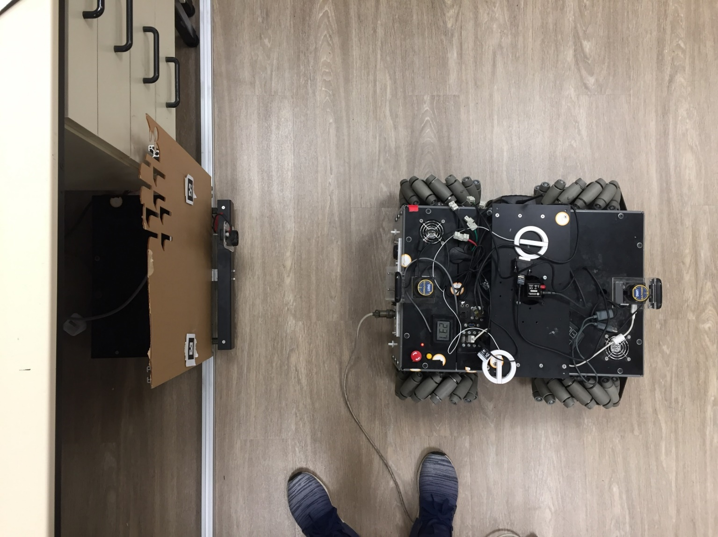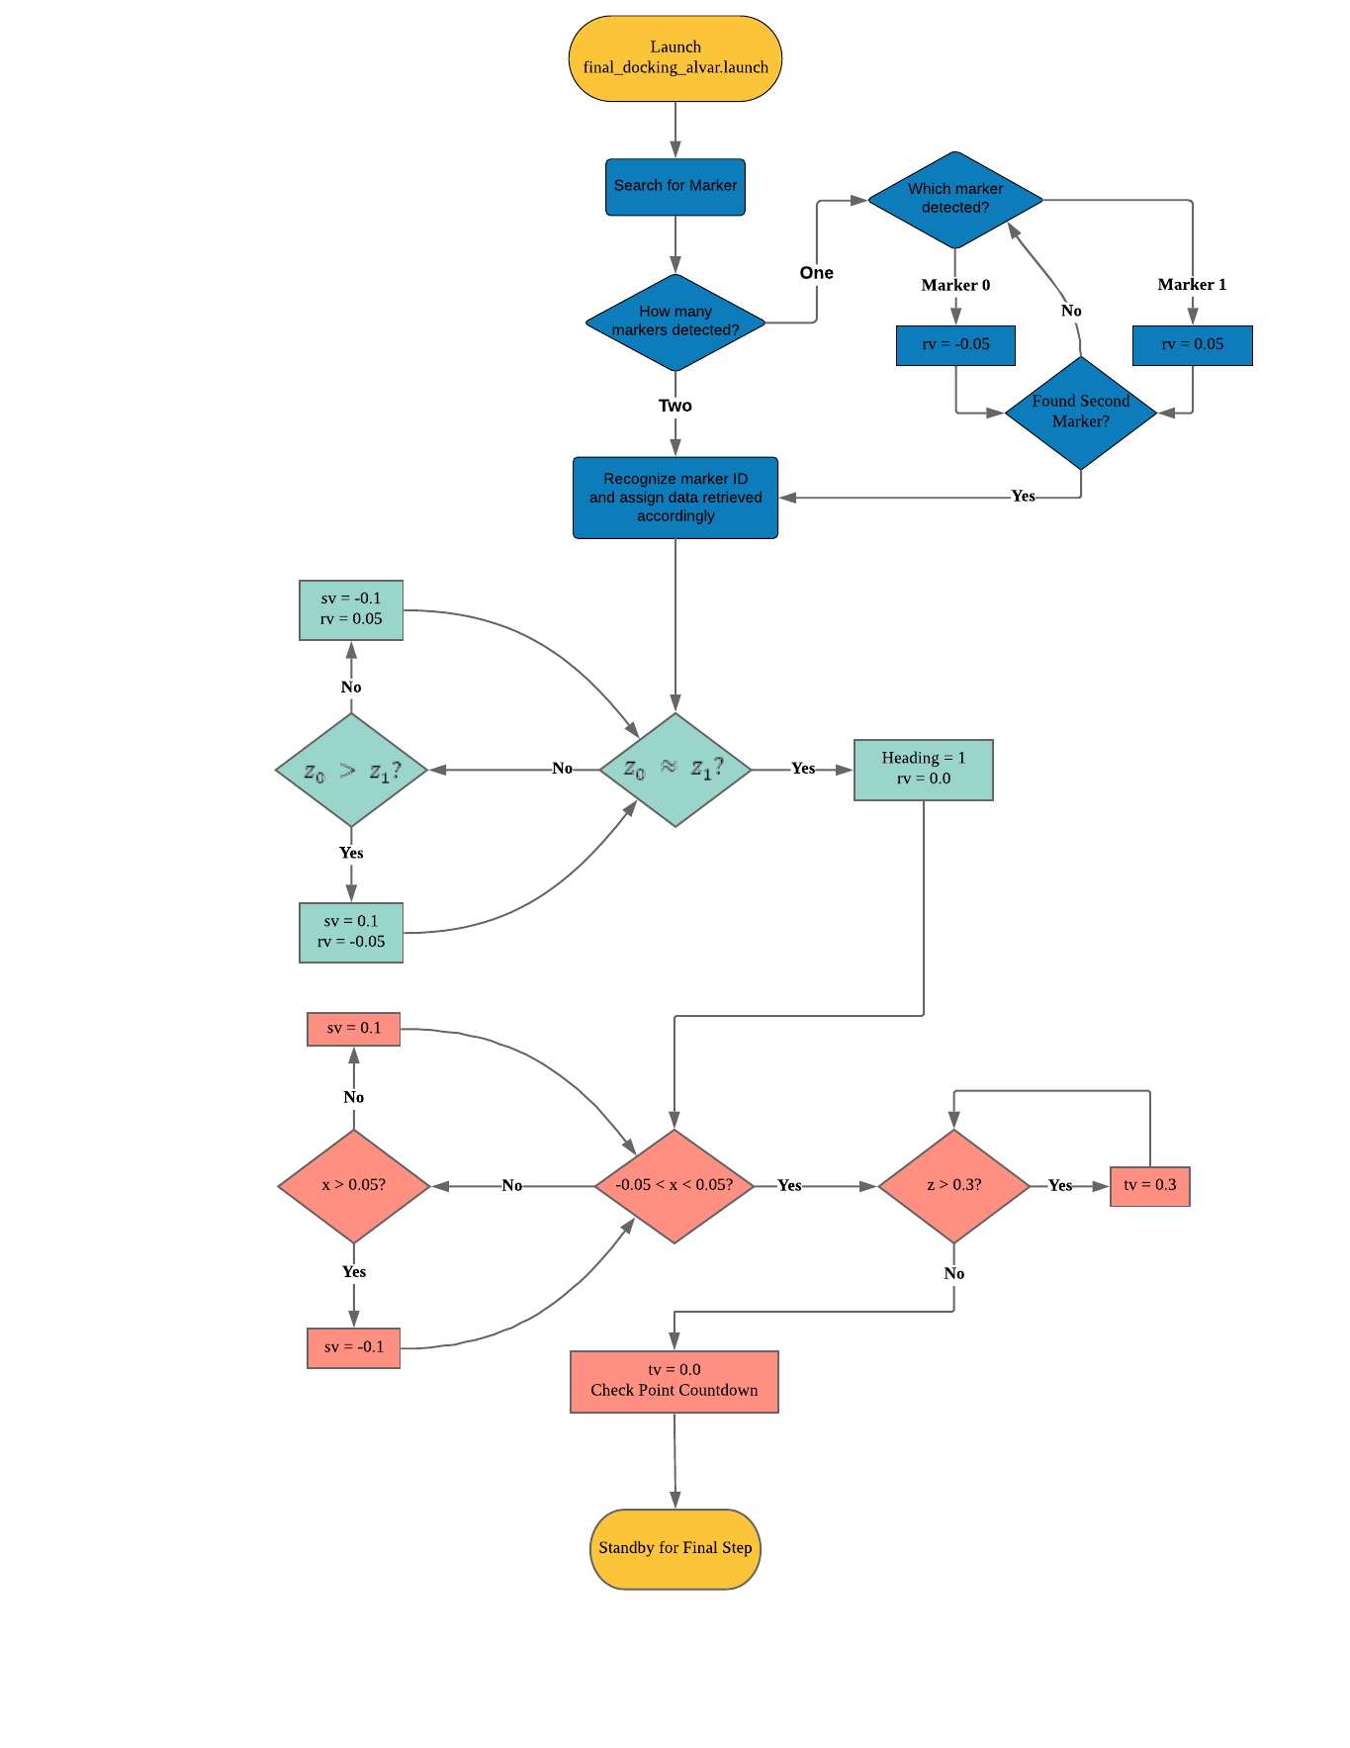As shown in Figure 21, the docking algorithm is further divided into 3 steps, the data checking and marker searching step, the orientation adjustment and moving toward centre step, and the last step of moving toward the centre and moving toward the check point.

Figure 20: Robot Navigation System Direction

**rv**

**sv**

**tv**

Figure 21: Docking Algorithm Flow Chart

**Adjust Orientation & Move toward Centre**

**Move toward Centre &**

**Move toward Check Point**

**Search for Marker &**

**Data Checking**

In the first step, the robot will proceed to search for both markers and perform some data checking. The details of detail checking will not be discussed but will be shown in the source code which can be found in the appendix.

After both markers have been found, the robot will adjust its orientation with respect to the station. At the same time, the robot will also try to move toward the centre. In this step, the main objective is to adjust the orientation of the robot, while move toward the centre is a side achievement, which will be fully accomplished in the next step.

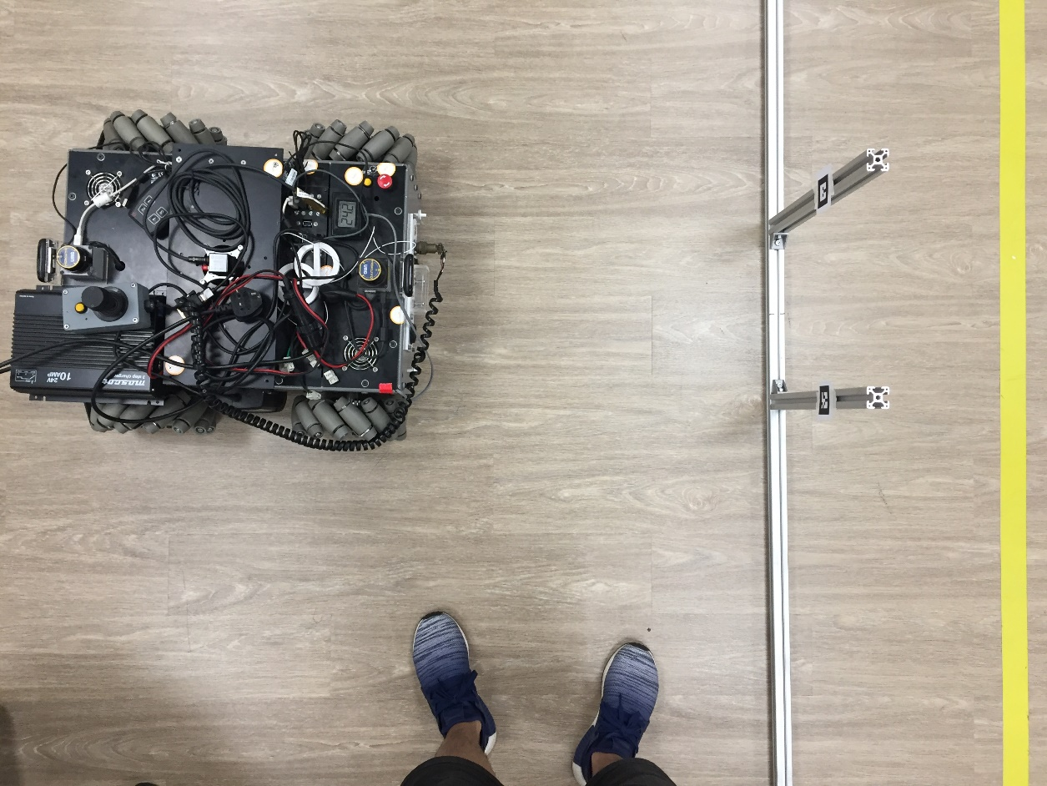In the last step, the heading of the robot will had been adjusted to the correct heading. Then, the robot will proceed to move toward the centre and try to move forward to the check point area. After the robot reached the check point area, a check point counter will be activated and will start to count down from a value predefined by the user. During the count-down is where the final step to move closer part starts. There will be a series of final check from the other node and the corresponding action will be explained in the next section.

Figure 22: Position of Robot at Check Point

### The Laser Docked Check Algorithm

After the robot reached the check point area, the check point countdown will start and the laser docked check algorithm will be notified of this event by the docking algorithm through the topic Final Check. Then, the laser docked check algorithm will start to check the robot orientation at the check point by validating all the data acquired from the laser. In the event of incorrect orientation, the laser docked check algorithm will inform the docking algorithm and the docking algorithm will reverse the robot to a predefined distance away from the station immediately. After that, the docking algorithm will gain back the control and proceed to dock again. If the orientation is correct throughout the count-down, the robot will move toward the station slowly for charging.

When the robot is moving toward the station after the count-down is finished, the laser docked check algorithm will also be notified about this event by the docking algorithm through the same topic Final Check. During this event, the laser docked check algorithm will constantly check the charging status and the distance between the robot and the station. This is to ensure that if the robot cannot dock successfully in this attempt, the robot will reverse to a predefined distance away from the station and try to dock again.

The detailed flow chart is shown in Figure 23. In Figure 23, the steps and decisions in green colour are those executed by the docking algorithm node, while those in blue colour are those executed by the laser docked check algorithm node.

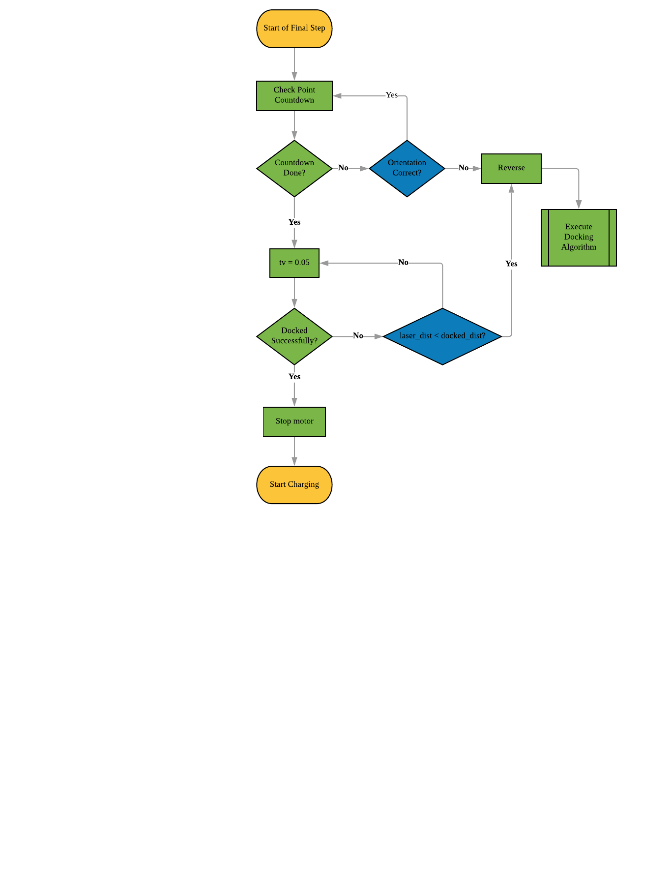The method used for the orientation check is to compare the mid-point distance with every other distance data from the Hokuyo laser. The information we need from the Hokuyo laser for the method used for the orientation check is the start scan angle, end scan angle, angle increment between each scan, and the distance data of every scan. The start scan angle and the end scan angle can be adjusted by the user, and more details will be discussed in the next section.

Figure 23: Final Check Flow Chart

Figure 24 shows the simplified version of the method used for the orientation check. The idea is that in a perfectly parallel position, the value of $a\cos{θ}$ and $b\cos{θ}$ should be the same as the value of the mid-point distance $m$. Extend this idea into a more general case, as shown in the equation below, where $l_{0}=m$, $l_{1}$ is the line adjacent to $m$, $l_{2}$ is the line adjacent to the line $l_{1}$ and so on.

$$m= l_{n}\cos\left(nθ\right) for n=1,2,3,…$$

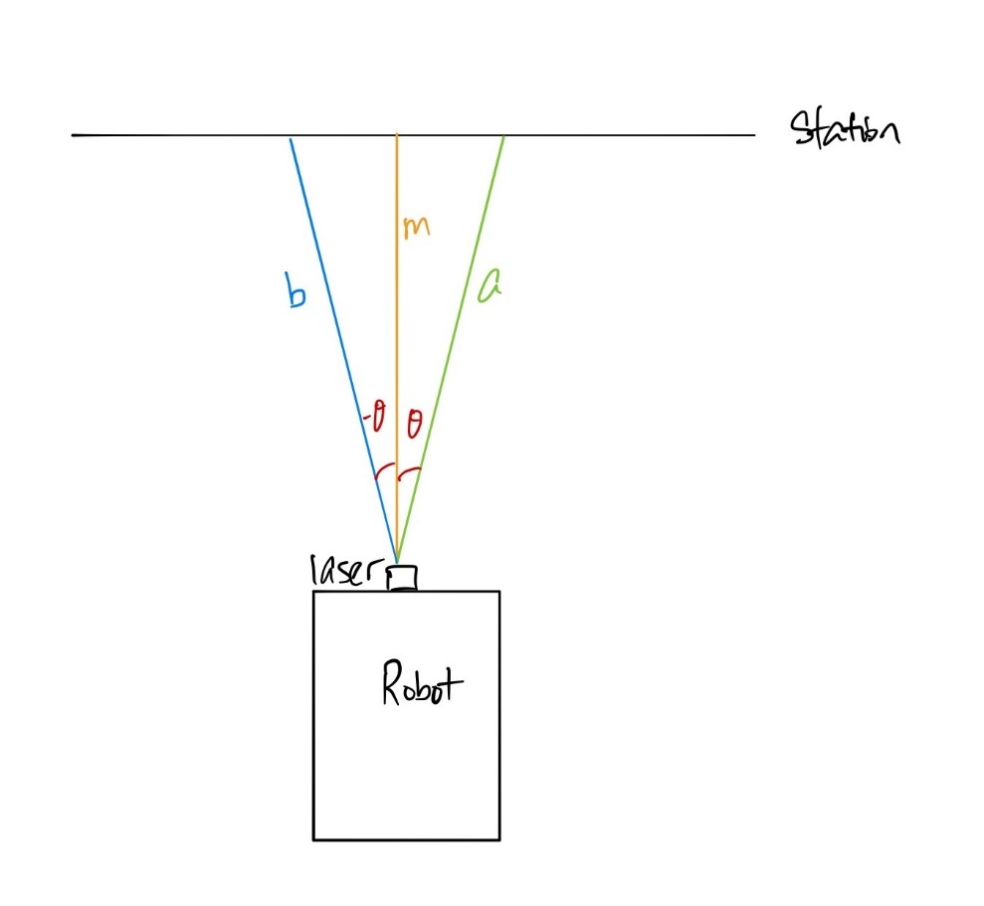

Figure 24: Orientation Check with Laser

For the second check in the laser docked check algorithm, the mid-point distance is compared with the distance when the robot is docked perfectly. This is to prevent the robot to keep moving toward the station when it fails to dock.

### Parameters and Fine Tuning

There are several “predefined values” required fine tuning or to be set by the user in the algorithm. These values are assigned with a parameter to be used in the algorithm and can be easily modified by the user for future use in the ROS launch file.

In this algorithm, there is a total of 8 different parameters to be set in order to function ideally. Table 4, Table 5 and Table 6 is the list of all parameters and the value assigned to it in this algorithm.

Table 4: List of Parameters in Docking Algorithm

|  |  |  |
| --- | --- | --- |
| Parameters | Definition | Values |
| zError | The error between $z_{0}$ and $z_{1}$ when the robot is perfectly parallel to the station, in meter | 0.03 |
| ReverseDistance | The distance for the reverse function to reach when it is triggered, in meter | 0.65 |
| CheckPointCount | The initial value to count down to 0 when the robot is at the check point area | 30 |

Table 5: List of Parameters in Laser Docked Check Algorithm

|  |  |  |
| --- | --- | --- |
| Parameters | Definition | Values |
| OrientValue | A benchmark to compare with the number of matches between mid-point distance and all other distances during orientation check | 17 |
| Tolerance | A tolerance for the comparison between the mid-point distance and all other distances when checking orientation using the laser, in meter | 0.015 |
| DockedDistance | The distance from the laser to the station when the robot is docked, for comparison when doing the second check, in meter | 0.178 |

Table 6: List of Parameters in hokuyo1 Node

|  |  |  |
| --- | --- | --- |
| Parameters | Definition | Values |
| min_ang | The angle of the first range measurement in radians | -0.110436619 |
| max_ang | The angle of the last range measurement in radians | 0.110446619 |

In Table 4, the parameters ReverseDistance and CheckPointCount can be set based on user preference. The larger the value of ChekcPointCount, the longer the robot will stay at the check point before moving towards the charging station. For the ReverseDistance, the value can be set within the range $\left[0.3, 0.9\right]$, this range is to ensure that the robot can detect the markers and stop reverse. Some factors to consider when choosing the value for the parameter ReverseDistance is the space for the robot to reposition itself and the time taken to reverse and reposition. For the parameter zError, the value is determined from the experiment and fine-tuning. The value 0.03 is the difference between $z_{0}$ and $z_{1}$ when the robot is in the correct orientation with respect to the station.

In Table 5, the parameter OrientValue can be set based on user preference. Currently, the range for this parameter is $\left[0, 18\right]$, but the range will be affected by the parameters set in Table 6. The higher the value for the parameter OrientValue, the tighter the allowance during the orientation check. For the parameters Tolerance and DockedDistance, several fine-tuning and experiments are carried out to obtain the values. For the parameter Tolerance, the value 0.015 is obtained from the average of all the difference between the mid-point distance and all other distances, as discussed in the previous section. For the parameter DockedDistance, the value 0.178 is the distance from the Hokuyo laser range finder to the station when the robot is in the docked and charging position.

In Table 6, the user can set both parameters based on their preference. Currently, the value set for the parameters are around $\left[-8°, 8°\right]$. However, when the value is changed, the value for the parameter OrientValue should be changed as well to achieve the same strictness in orientation check. The angle increment between each scan is $0.3516°$, which is not discussed in this report but can be seen in the appendix. Hence, the new range for the parameter OrientValue will be $\left[0, n\right]$ where $n$ can be calculated using the equation below.

$$n= \frac{\left|max⁡_ang\right|-|min⁡_ang|}{2×angle increment}$$

## Charging Station Framework and Placement



There are in total 3 versions of charging station framework constructed throughout this project. All 3 versions of the charging station framework are shown in the figures below.



Figure 25: First Version of Charging Station Framework

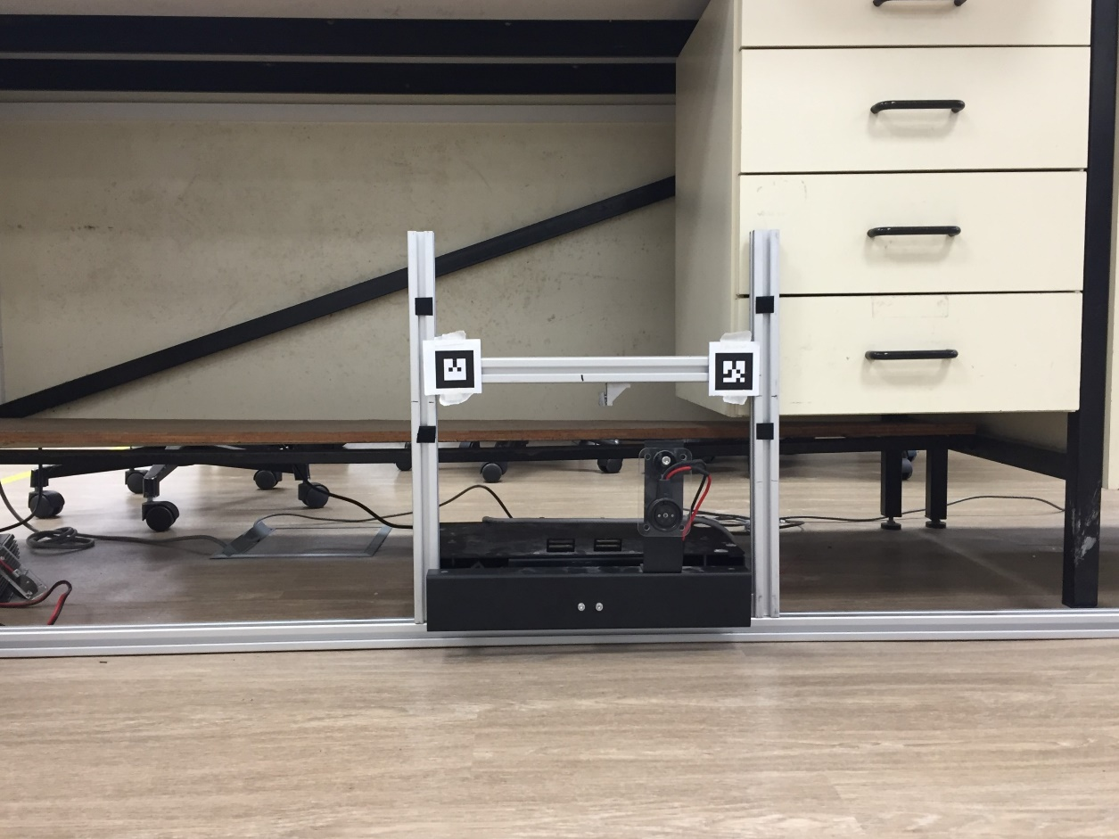The first version is a simple framework to put the two markers on the desired height from the ground. The second version is constructed due to the insufficient space in the first version to put the charging station from the previous FYP work in the middle of the 2 metal bars.

Figure 26: Second Version of Charging Station Framework

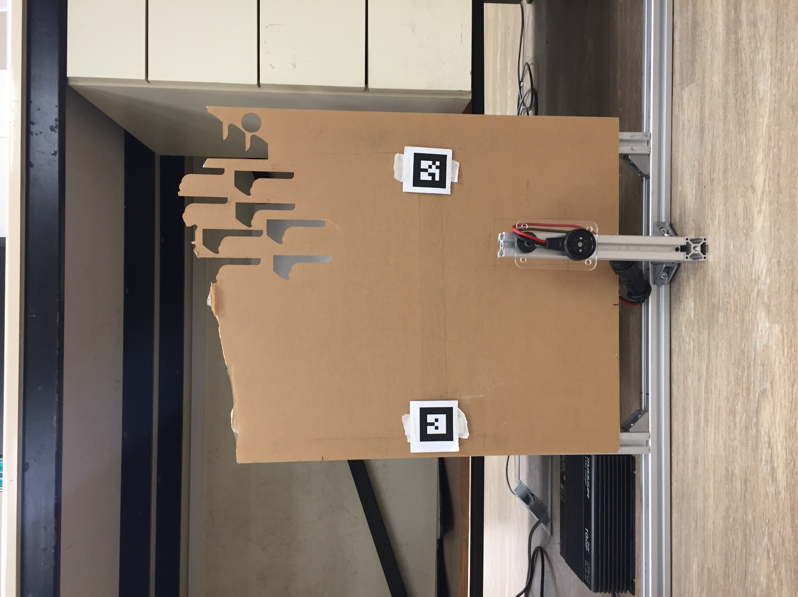In order to implement the laser docked check algorithm, the station has to be a flat surface for the method of orientation check to work. Besides, the charging station from the previous FYP work is replaced by a simpler design of another metal bar to hold the charger in place. This is to ensure the fixed placement of the charger from the markers as the placement is a crucial factor in the docking process. The details placement and measurement of the station can be seen in Figure 28.

Figure 27: Final Version of Charging Station Framework

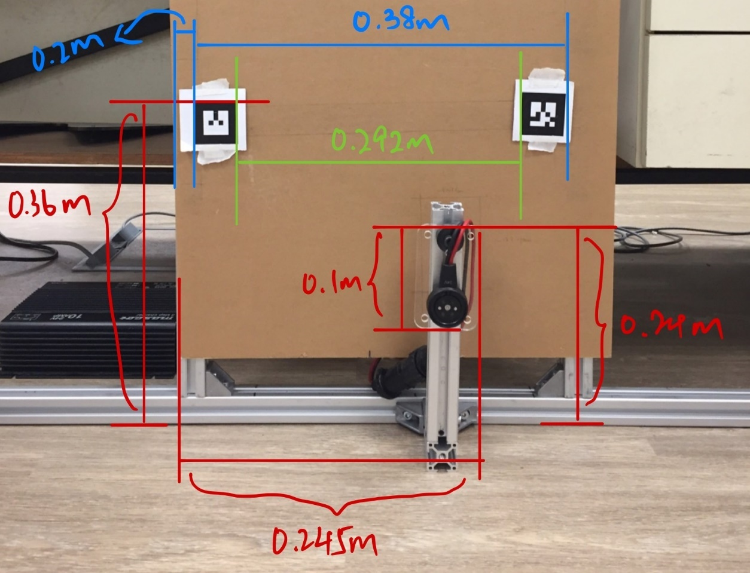The size of both markers is 4.4cm by 4.4cm (0.044m). Every measurement is started from either the left side or from the ground. The placement between the markers and the charger on the station is extremely important as the docking algorithm will base on the 2 markers location and dock accordingly.

Figure 28: Charging Station Placement

1. Experiment

An experiment is designed to test the accuracy of the docking system. The mechanism from the previous FYP work is not used in the experiment, this is to visualize the accuracy and improvement in the aspect of software algorithm. The setup of the experiment and data collected is explained in detail in the following section.

## Experiment Setup and Procedure

The final version of the charging station, as shown in Figure 27, was placed on a fixed location. The placement of the 2 markers and the charger on the station was adjusted according to the standard placement shown in Figure 28.

After the setup of the station is finished, the robot was moved to a location 0.8m away from the station. There is a total of 7 different scenarios that were tested in this experiment, which are listed below. Every scenario was tested with 10 runs.

1. Robot in the middle detecting 2 markers originally
2. Robot in the middle detecting marker 0 originally
3. Robot in the middle detecting marker 1 originally
4. Robot in the left detecting 1 marker originally
5. Robot in the left detecting 2 markers originally
6. Robot in the right detecting 1 marker originally
7. Robot in the right detecting 2 markers originally

After that, the required algorithms were started and a stopwatch was used to record the time required for the robot to dock successfully. After each run, the robot was returned to the position 0.8m away from the station to start another run. The placement of the station was constantly being checked to ensure it follows the standard placement. The steps were repeated until all the scenarios were experimented.

## Experiment Data

In this experiment, there are several types of data are recorded and will be discussed in the following chapter. The time required for the robot to dock successfully is recorded.

Besides, the number of trials used in each run to dock successfully is also recorded. This is to check how accurate is the docking algorithm with only using the camera and the markers to position the robot.

Moreover, the types of trials will be recorded as well. To elaborate, as discussed in the laser docked check algorithm section, there are 2 checks performed which are the orientation check and the check of whether the robot docked successfully. If either of the 2 checks is not passed, the robot will reverse to a predefined location and reposition itself, and the check that is not passed will be recorded. This is to measure the effectiveness of the laser docked check algorithm in improving the functionality and reliability of the whole docking system.

1. Result and Discussion

## Result

The result of the experiment is shown in the tables below. The recorded time required to dock successfully in the tables includes the time taken for the robot to reverse and the count-down time required at the check point. The time taken for these standard actions is listed in Table 7.

Table 7: Time Required for the Standard Actions

|  |  |
| --- | --- |
| Actions | Time Taken (s) |
| Finish count down at the check point | 3 |
| Reverse due to incorrect orientation at check point | 5 |
| Reverse due to unsuccessful docking | 9 |

Table 8: Result for Scenario 1

|  |  |  |  |  |  |
| --- | --- | --- | --- | --- | --- |
| Test No. | Trials Taken | Incorrect Orientation | Unsuccessful Docked | Time Required (s) | Time Taken for Standard Actions (s) |
| 1 | 4 | 1 | 2 | 85 | 35 |
| 2 | 3 | 2 | 0 | 42 | 19 |
| 3 | 4 | 0 | 3 | 99 | 39 |
| 4 | 2 | 1 | 0 | 26 | 11 |
| 5 | 7 | 2 | 4 | 147 | 67 |
| 6 | 5 | 1 | 3 | 107 | 47 |
| 7 | 1 | 0 | 0 | 18 | 3 |
| 8 | 5 | 2 | 2 | 96 | 43 |
| 9 | 1 | 0 | 0 | 16 | 3 |
| 10 | 1 | 0 | 0 | 17 | 3 |
| Avg | 3.3 | 0.9 | 1.4 | 65.3 | 27.0 |

Table 9: Result for Scenario 2

|  |  |  |  |  |  |
| --- | --- | --- | --- | --- | --- |
| Test No. | Trials Taken | Incorrect Orientation | Unsuccessful Docked | Time Required (s) | Time Taken for Standard Actions (s) |
| 1 | 2 | 0 | 1 | 48 | 15 |
| 2 | 4 | 0 | 3 | 99 | 39 |
| 3 | 2 | 1 | 0 | 34 | 11 |
| 4 | 2 | 0 | 1 | 46 | 15 |
| 5 | 1 | 0 | 0 | 20 | 3 |
| 6 | 4 | 0 | 3 | 103 | 39 |
| 7 | 1 | 0 | 0 | 19 | 3 |
| 8 | 1 | 0 | 0 | 20 | 3 |
| 9 | 1 | 0 | 0 | 22 | 3 |
| 10 | 4 | 1 | 2 | 88 | 35 |
| Avg | 2.2 | 0.2 | 1 | 49.9 | 16.6 |

Table 10: Result for Scenario 3

|  |  |  |  |  |  |
| --- | --- | --- | --- | --- | --- |
| Test No. | Trials Taken | Incorrect Orientation | Unsuccessful Docked | Time Required (s) | Time Taken for Standard Actions (s) |
| 1 | 7 | 2 | 4 | 155 | 67 |
| 2 | 6 | 1 | 4 | 141 | 59 |
| 3 | 1 | 0 | 0 | 24 | 3 |
| 4 | 5 | 1 | 3 | 115 | 47 |
| 5 | 1 | 0 | 0 | 21 | 3 |
| 6 | 3 | 0 | 2 | 75 | 27 |
| 7 | 2 | 1 | 0 | 30 | 11 |
| 8 | 3 | 1 | 1 | 61 | 23 |
| 9 | 1 | 0 | 0 | 20 | 3 |
| 10 | 6 | 1 | 4 | 139 | 59 |
| Avg | 3.5 | 0.7 | 1.8 | 78.1 | 30.2 |

Table 11: Result for Scenario 4

|  |  |  |  |  |  |
| --- | --- | --- | --- | --- | --- |
| Test No. | Trials Taken | Incorrect Orientation | Unsuccessful Docked | Time Required (s) | Time Taken for Standard Actions (s) |
| 1 | 3 | 1 | 1 | 73 | 23 |
| 2 | 1 | 0 | 0 | 18 | 3 |
| 3 | 1 | 0 | 0 | 22 | 3 |
| 4 | 6 | 2 | 3 | 123 | 55 |
| 5 | 1 | 0 | 0 | 21 | 3 |
| 6 | 4 | 0 | 3 | 108 | 39 |
| 7 | 1 | 0 | 0 | 17 | 3 |
| 8 | 1 | 0 | 0 | 17 | 3 |
| 9 | 7 | 3 | 3 | 144 | 63 |
| 10 | 5 | 2 | 2 | 97 | 43 |
| Avg | 3.0 | 0.8 | 1.2 | 64.0 | 23.8 |

Table 12: Result for Scenario 5

|  |  |  |  |  |  |
| --- | --- | --- | --- | --- | --- |
| Test No. | Trials Taken | Incorrect Orientation | Unsuccessful Docked | Time Required (s) | Time Taken for Standard Actions (s) |
| 1 |  |  |  |  |  |
| 2 |  |  |  |  |  |
| 3 |  |  |  |  |  |
| 4 |  |  |  |  |  |
| 5 |  |  |  |  |  |
| 6 |  |  |  |  |  |
| 7 |  |  |  |  |  |
| 8 |  |  |  |  |  |
| 9 |  |  |  |  |  |
| 10 |  |  |  |  |  |

Table 13: Result for Scenario 6

|  |  |  |  |  |  |
| --- | --- | --- | --- | --- | --- |
| Test No. | Trials Taken | Incorrect Orientation | Unsuccessful Docked | Time Required (s) | Time Taken for Standard Actions (s) |
| 1 |  |  |  |  |  |
| 2 |  |  |  |  |  |
| 3 |  |  |  |  |  |
| 4 |  |  |  |  |  |
| 5 |  |  |  |  |  |
| 6 |  |  |  |  |  |
| 7 |  |  |  |  |  |
| 8 |  |  |  |  |  |
| 9 |  |  |  |  |  |
| 10 |  |  |  |  |  |

Table 14: Result for Scenario 7

|  |  |  |  |  |  |
| --- | --- | --- | --- | --- | --- |
| Test No. | Trials Taken | Incorrect Orientation | Unsuccessful Docked | Time Required (s) | Time Taken for Standard Actions (s) |
| 1 |  |  |  |  |  |
| 2 |  |  |  |  |  |
| 3 |  |  |  |  |  |
| 4 |  |  |  |  |  |
| 5 |  |  |  |  |  |
| 6 |  |  |  |  |  |
| 7 |  |  |  |  |  |
| 8 |  |  |  |  |  |
| 9 |  |  |  |  |  |
| 10 |  |  |  |  |  |

Table 15: Average Result of All Scenarios

|  |  |  |  |  |  |
| --- | --- | --- | --- | --- | --- |
| Scenarios Average | Trials Taken | Incorrect Orientation | Unsuccessful Docked | Time Required (s) | Time Taken for Standard Actions (s) |
| 1 | 3.3 | 0.9 | 1.4 | 65.3 | 27.0 |
| 2 | 2.2 | 0.2 | 1 | 49.9 | 16.6 |
| 3 | 3.5 | 0.7 | 1.8 | 78.1 | 30.2 |
| 4 | 3.0 | 0.8 | 1.2 | 64.0 | 23.8 |
| 5 |  |  |  |  |  |
| 6 |  |  |  |  |  |
| 7 |  |  |  |  |  |

## Discussion

Discuss the improvement of error with this new algorithm. The mechanical mechanisms can be reduced into smaller shape due to only slight movement needed to overcome the docking error

Discuss hokuyo laser might be a better choice because can provide a more accurate result. Briefly explain how to work with a laser (distance from 2 points is the same). The laser is getting cheaper nowadays, so it is affordable compare to olden days that camera is way cheaper than laser.

Such algorithm can also be used for wireless charging. Wireless charging requires less accuracy compared to contact charging. Hence, this algorithm is accurate enough to implement on wireless charging.

1. Conclusion

Wrap up and list out future work can be done: 1. Design docking station according to the error of this new algorithm, 2. Utilize hokuyo laser to develop new algorithm, 3. Possible to fuse 2 data from camera and laser 4. Reduce the number of trials

References

[1] “robot | Definition of robot in English by Oxford Dictionaries.” [Online]. Available: https://en.oxforddictionaries.com/definition/robot. [Accessed: 18-Mar-2019].

[2] R. C. Allen, “The British Industrial Revolution in Global Perspective:How Commerce CreatedThe Industrial Revolution and Modern Economic Growth,” *Unpublished*, pp. 1–41, 2014.

[3] N. Viswanadham, “The Past, Present, and Future of Supply-Chain Automation,” *IEEE Robotics & Automation Magazine*, 2002.

[4] I. Iglesias, M. A. Sebastián, and J. E. Ares, “Overview of the state of robotic machining: Curren situation and future potential,” *Procedia Eng.*, vol. 132, pp. 911–917, 2015.

[5] G. Q. Huang, M. Z. Q. Chen, and J. Pan, “Robotics in ecommerce logistics,” *HKIE Trans. Hong Kong Inst. Eng.*, vol. 22, no. 2, pp. 68–77, 2015.

[6] D. L. Bayles and H. Bhatia, *E-Commerce Logistics & Fulfillment: Delivering the Goods*. Upper Saddle River, NJ, USA: Prentice Hall PTR, 2000.

[7] O. T. Tang and T. Liu, “China Logistics,” 2014. [Online]. Available: http://www.kimeng.com.hk/upload/research_reports/ChinaLogistics_20140723_IC.pdf. [Accessed: 18-Mar-2019].

[8] D. Floreano and F. Mondada, “Evolution of homing navigation in a real mobile robot,” *IEEE Trans. Syst. Man, Cybern. Part B Cybern.*, vol. 26, no. 3, pp. 396–407, 1996.

[9] R. C. Luo, C. T. Liao, K. L. Su, and K. C. Lin, “Automatic docking and recharging system for autonomous security robot,” *2005 IEEE/RSJ Int. Conf. Intell. Robot. Syst. IROS*, pp. 1536–1541, 2005.

[10] M. Hajduk, P. Jenčík, J. Jezný, and L. Vargovčík, “Trends in Industrial Robotics Development,” *Appl. Mech. Mater.*, vol. 282, pp. 1–6, 2013.

[11] S.-G. Roh *et al.*, “Flexible docking mechanism with error-compensation capability for auto recharging system of mobile robot,” *Int. J. Control. Autom. Syst.*, vol. 6, no. 5, 2008.

[12] W. G. Walter, *The living brain.* Oxford, England: W. W. Norton, 1953.

[13] Y. Hada and I. R. Labolatory, “Long term activity of the autonomous robot Proposal of,” no. October, pp. 1871–1878, 1998.

[14] R. C. Arkin and R. R. Murphy, “Autonomous Navigation in a Manufacturing Environment,” *IEEE Trans. Robot. Autom.*, vol. 6, no. 4, pp. 445–454, 1990.

[15] K. Roufas, Y. Zhang, D. Duff, and M. Yim, “Six Degree of Freedom Sensing For Docking Using IR LED Emitters and Receivers,” *Exp. Robot. VII*, pp. 91–100, 2000.

[16] M. C. Silverman, D. Nies, B. Jung, and G. S. Sukhatme, “Staying alive: a docking station for autonomous robot recharging,” in *Proceedings 2002 IEEE International Conference on Robotics and Automation (Cat. No.02CH37292)*, 2002, vol. 1, pp. 1050–1055 vol.1.

[17] G. Song, H. Wang, J. Zhang, and T. Meng, “Automatic docking system for recharging home surveillance robots,” *IEEE Trans. Consum. Electron.*, vol. 57, no. 2, pp. 428–435, 2011.

[18] “roslaunch - ROS Wiki.” [Online]. Available: http://wiki.ros.org/roslaunch. [Accessed: 23-Mar-2019].

[19] G. Seet *et al.*, “A design for a mobile robotic avatar - Modular framework,” *3DTV-Conference*, pp. 1–4, 2012.

[20] “ar_track_alvar - ROS Wiki.” [Online]. Available: http://wiki.ros.org/ar_track_alvar. [Accessed: 23-Mar-2019].

[21] “ar_pose - ROS Wiki.” [Online]. Available: http://wiki.ros.org/ar_pose. [Accessed: 23-Mar-2019].

Appendix

Source Code available at: <https://github.com/JNPoon/FYP18-19_AutomaticDocking>